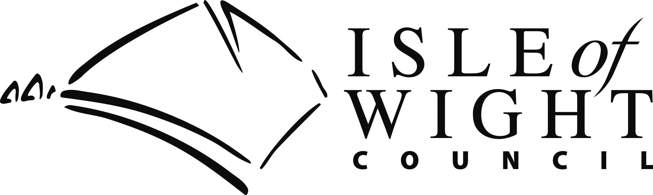
Housing Benefit and Local Council Tax
Support for the Self-employed

Can I get Housing Benefit and Local Council Tax Support if I am self-employed?

Yes, anyone with a low income may be able to get help subject to the conditions of entitlement being met.

The amount we can pay depends on your income, including self-employed earnings, savings and your personal circumstances.

What extra information will I need to provide?

If you have been working as a self-employed person for twelve complete calendar months or more, please provide details of your income and expenses for your last financial year.

If you have been working as self-employed for less than one financial year, please provide details of your income and expenses for as many complete calendar months as you can.

If you have been working as a self-employed person for less than one month please provide details of your estimated income and expenses for the first three months of trading.

The calculation of Housing Benefit and Local Council Tax Support can be complex and we might need to ask you to provide extra information and evidence of your expenses to allow us to calculate your claim correctly. If we do need to ask you for more information it will take us longer to award you benefit.

How will you calculate my income?

As you are self-employed we need extra information from you to work out your weekly earnings (after tax) from your business and add this to any other income you and your family receive.

To work out your earnings for benefit purposes, we need to work out your profit before taxation. We will then take away any allowable amounts you have had to spend to run your business.

We will base your earnings over a specified trading period. This will reflect the flow of cash into and out of the business.

We do not take away any personal or household expenses or savings. We also do not take away the cost of starting up or expanding your business.

Please be advised that if you have been gainfully self-employed in your business for more than 1 year, you will be subject to a minimum income floor based on the minimum wage.
A minimum income floor will be applied if the income from your self-employment is less than 35 hours x the hourly national living wage for an ordinary employed worker. The Local Authority will use that amount in the calculation of income for reduction purposes. From this figure we will deduct an estimate for tax, NI and half a pension contribution (if being paid), as if estimating the income of an ordinary employed person.

Can you use my most recent tax assessment as proof of income?

No, Housing Benefit and Local Council Tax Support rules are different from tax rules so we cannot use your tax assessment. Similarly we cannot base your income on the amount used in the Working Tax Credit assessment.

Please read and carefully complete all parts of the form that are applicable to you.

About You
Name |  |  |  |  |  |  |  |  |  |  |  | Phone Number
Address |  |  |  |  |  |  |  |  |  |  |  | Benefit Claim Reference Number
 |  |  |  |  |  |  |  |  |  |  |  | Business address
Post Code
About your business
What is the name of your business?
What is the nature of your business?
Please provide a brief description of your normal daily work. Please include things like time spent using telephone, car and working from home etc.
What date did your business commence?
Average hours worked per week
Start date of your current financial year
Is your business a partnership? |  |  |  |  |  |  |  |  |  |  |  | Yes |  |  |  |  |  |  | No
If yes, what percentage of the total profit/loss is yours?
What is your Business Partner(s) name?
Do you have audited accounts to provide? |  |  |  |  |  |  |  |  |  |  |  | Yes |  |  |  |  |  |  | No
If yes please enclose a copy of your latest profit and loss accounts. Please now read and sign the declaration.
If you do not have audited accounts to provide, if your business is a new business and you do not have a set of accounts prepared, or you do not use an accountant, please complete the statements of account below and on the following page.
Personal Pension Contributions |  |  |  |  |  |  |  |  |  |  | £ |  |  |  |  |  |  |  | per
Please provide proof of the scheme to which you belong and of the payments made.
If you are not able to submit audited accounts please continue.
This statement is for the following period.
From |  |  |  |  |  |  |  |  |  |  |  | To
Sales taking & income |  |  |  |  |  |  |  |  |  |  |  | Tips & commission
Other income |  |  |  |  |  |  |  |  |  |  |  | Business start up Allowance
(Specify)
Gross Profit
National Insurance Contributions
Do you hold an exemption certificate? |  |  |  |  |  |  |  |  |  |  |  | Yes |  |  |  |  |  |  | No
 | Breakdown of Expenses
 | Type of expense |  |  |  |  |  |  |  |  | Actual Expense |  |  |  |  | Estimated expenses (only use if you have just started self employment) |  |  |  |  |  | % personal use
 | Purchase of stock/supplies/materials
 | Vehicle insurance
 | Vehicle tax
 | Vehicle servicing and maintenance
 | Vehicle fuel
 | Additional travel costs e.g. train fares
 | Replacement costs of tools/equipment
 | Staff wages
 | Public Liability Insurance
 | Property Insurance
 | Accountancy
 | Rent for business premises
 | Repairs & cleaning of business premises
 | Business rates
 | Utility costs for business premises
 | Business loan
 | Interest payments
 | Capital repayments (enclose agreement)
 | Bank charges on business account
 | Landline telephone/broadband
 | Mobile
 | Stationery, printing and postage
 | Advertising
 | Use as home as office
 | Hire and leasing charges
 | Subscriptions to professional bodies
 | VAT paid in excess
 | VAT received
 | Proven bad debts
 | Expenses incurred in recovery of a debt
 | Other (please specify)
Declaration
I understand that my benefit will be assessed based on my latest accounts (or statement of accounts) and will be reassessed when the appropriate years accounts are available.
I declare that to the best of knowledge all the information given in this application is correct. I have no other income as a self-employed person other than that declared. I authorise Isle of Wight Council to make any enquires they so wish to verify the information I have given, including direct enquiries to HM Inspector of Taxes. I undertake to inform the Benefit Section of any changes in my circumstances which may alter my entitlement to Housing Benefit and/or Local Council Tax Support.
Signed
Date

Please post to Isle of Wight Council, Revenues and Benefit Services, PO Box 238, Newport, PO30 9FP

Alternatively, once completed by the appropriate person the form may be scanned and emailed to housing.benefit@iow.gov.uk or upload through our customer portal which is quick, simple and easy to use by visiting www.iwight.com

For further information on Housing Benefit or Local Council Tax Support, please visit www.iwight.com

