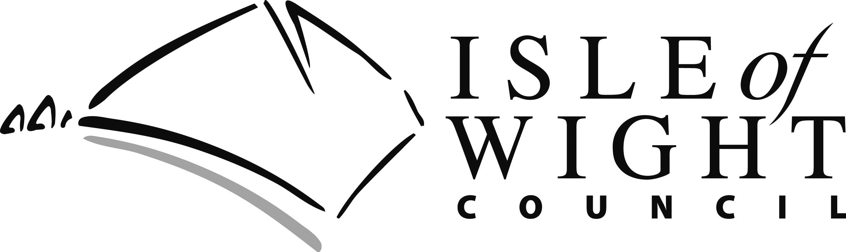

BENEFIT ON TWO HOMES

Occasionally you may be liable to pay rent on two properties at the same time, for example when you are moving home. If you already get Housing Benefit and Local Council Tax Support, in some special circumstances you could receive payment on two homes.

When Would Benefit Be Paid On Two Homes?

We can consider paying benefit on two homes in the following circumstances:

- You are in fear of violence:
- You are a student or trainee:
- You are a large family;
- There is an unavoidable overlap while moving.

Fear of Violence

If a person has to stay away from their normal home as they are in fear of violence, Housing Benefit can be paid on that home and the other home for up to 52 weeks maximum as long as there is an intention to return to the normal home. As soon as the intention to return to the normal home stops, then benefit must be ended on the Sunday of that week. If there is no intention to return, Housing Benefit can only be paid for four weeks maximum. The property cannot be sublet whilst the person is absent from their normal home.

Evidence to support this payment would be required i.e Police incident report.

Student/trainees

We can pay benefit on two homes if you or your partner are a student on a training course, entitled to benefit and it is:

- Unavoidable that you need to have two homes;
- Reasonable in the circumstances that benefit should be paid on two homes.

Cont..
There is no time limit on the payment, as long as we are satisfied that the occupation of two homes is unavoidable.

Evidence: Information about your course and confirmation of the reason that it is unavoidable to have two properties

Large Families

If the Local Authority have housed your family in two separate properties because of the size of your family, we will treat you as occupying both properties as your home and we will pay benefit on both. Both homes must have been provided, but not necessarily owned by the council. Housing Benefit can be paid on two homes indefinitely.

Unavoidable overlap while moving home

We can pay Housing Benefit and Local Council Tax Support for up to a maximum of four weeks on both homes in either of the following situations:

- If you cannot move into your new home straight away because it is being adapted to meet the needs of a member of your family who is disabled; or

- If you have had to move in to your new home before the period of notice on your old home has ended and this was unavoidable.

Making a claim for benefit on two homes

Please contact us as soon as possible.

You will be required to provide the following:

- Proof of the date that the liability to pay rent at your old property ends
- Confirmation of the date you gave your landlord notice that you were leaving the property.
- The date that you actually moved out
- Proof that the property will not be re let during the period of notice.

We also require:

- Proof of the date the tenancy was offered to you. You should have received an offer letter.
- Proof of the date that you accepted the tenancy. A copy of your new agreement will show this.
- Confirmation of the date you actually moved into the address (If you used a removal firm or hired a vehicle, a receipt to confirm this will show the date of the move)
- The reason for the move and when you decided you were definitely leaving your previous property.

Contacting Us

Documentation and evidence can be scanned and emailed to:

housing.benefit@iow.gov.uk

Alternatively you can post the information to:

Revenues and Benefits Service
PO Box 238
Newport
Isle of Wight
PO30 9FP

Further information can be found on our website www.iwight.com/housingbenefitonline

