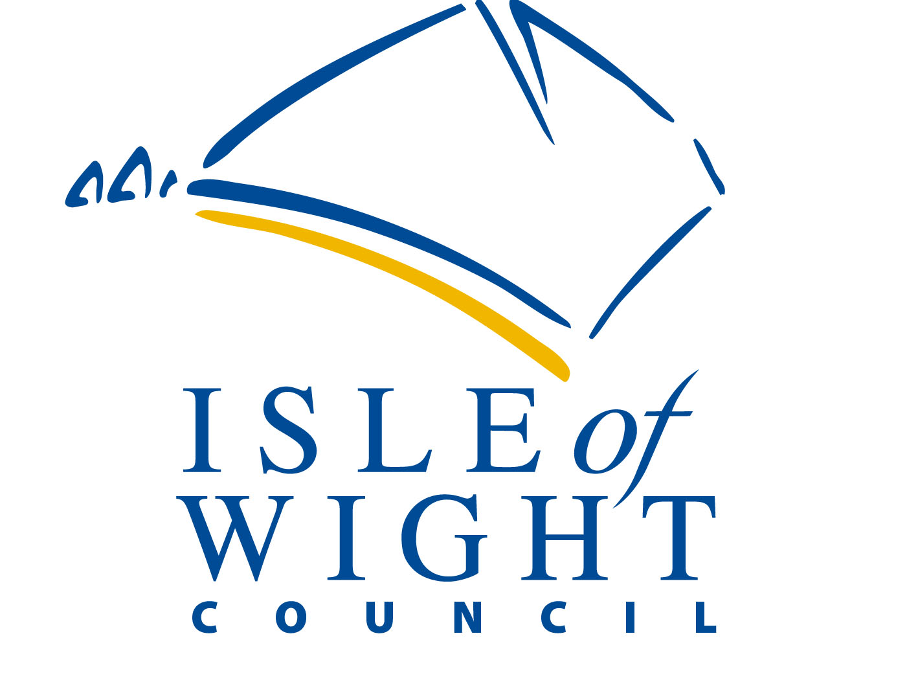
EDUCATION HEALTH CARE PLAN
Part 2 is all about you. This is your chance to tell everyone that
Supports you what’s going well and what needs to change to help
you succeed. The following questions will help us to understand
more about you and your views about your life.

Photo
(optional)

All about me

Name: _____________________________________

I could do even better if:
New things I would like to try or get better at:
Things that I find difficult are:
What you need to know to support me:
How I communicate:
Things that I like and things I am really good at:
People who are important to me are:

Please return to sen@iow.gov.uk

