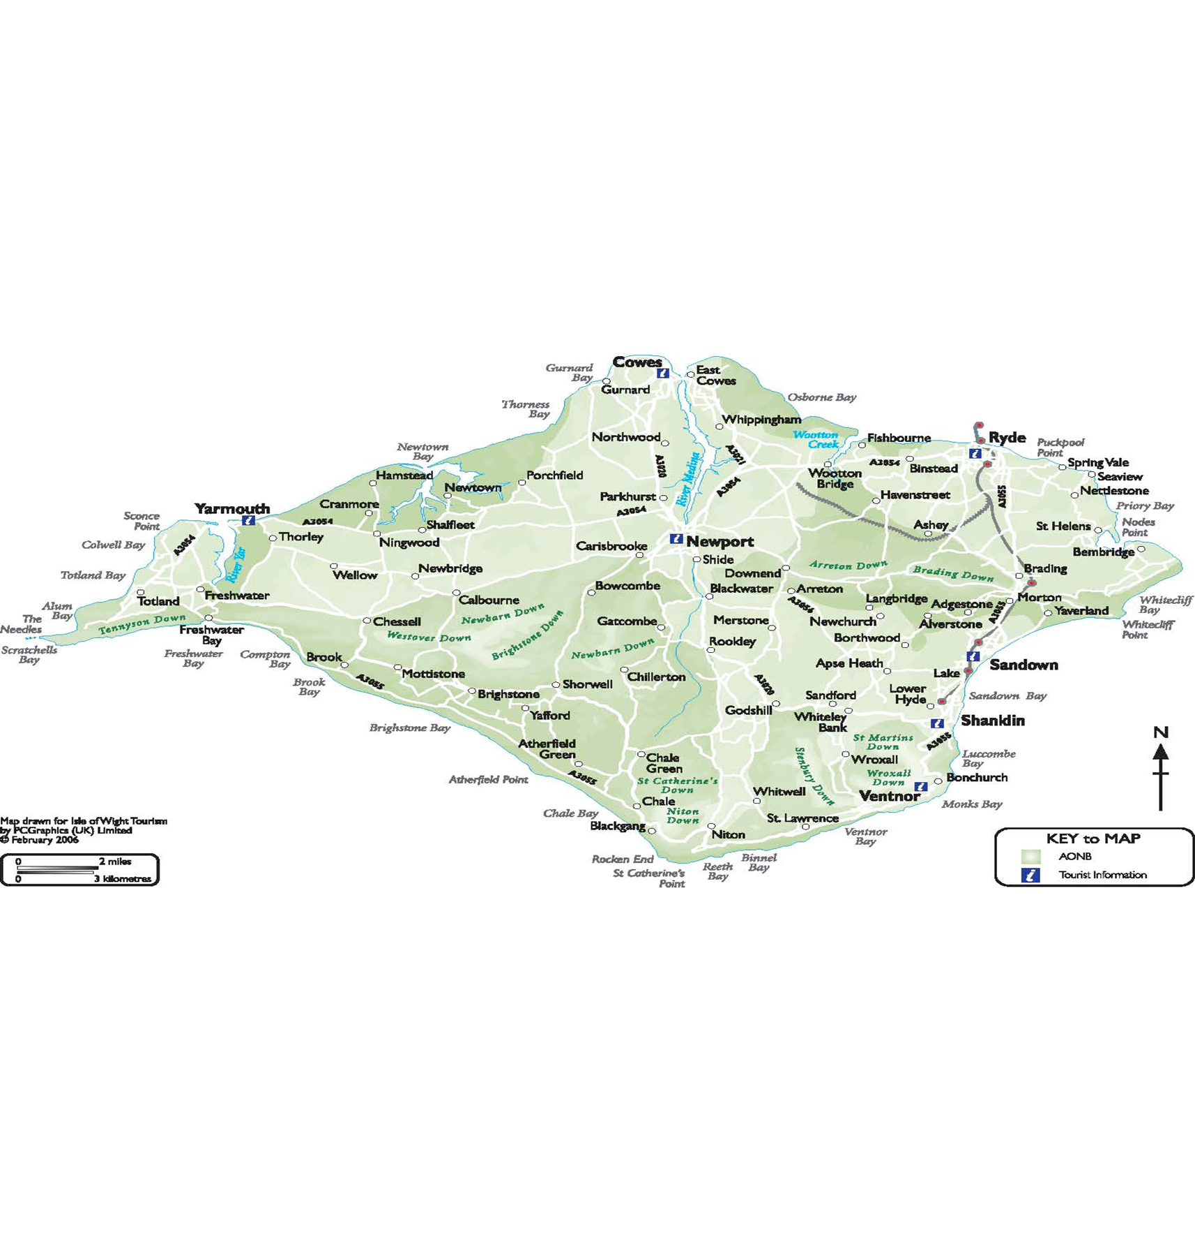

**Early Help Business Support Officer- Yolanda Gavaghan**

[Yolanda.gavaghan@iow.gov.uk](mailto:Yolanda.gavaghan@iow.gov.uk)

019838231000 ext 6776

**North East and South Wight- Carly Bain**

[Carly.bain@iow.gov.uk](mailto:Carly.bain@iow.gov.uk)

01983821000 ext 6277

**Early Help Co-ordinators Locality Map**

Earlyhelp@iow.gov.uk

**West Central Wight + Sandown – Carol Attrill**

[Carol.attrill@iow.gov.uk](mailto:Carol.attrill@iow.gov.uk)

01983821000 ext 6725

**= Carly Bain**

**=Carol Attrill**