Citizen Access Landlords
User Guide

Change control table:
Version | Status | Release date | Reason for change | Changed by
1.0 | live | April 2019 | New | E Rhodes
2.0 | Live | November 2020 | Addition for entitlement letters | E.Rhodes

Table of Contents
 | Purpose of this guide | 4
 | Introduction | 4
 | Logging in and out of Citizens Access Landlords | 5
3.1. | Logging in for the first time | 5
3.2. | Signing in | 5
3.3. | Logging out | 6
 | Using Citizen Access Landlords | 6
4.1. | Maintain Users | 6
4.2. | My Profile | 7
4.3. | View payments | 8
4.4. | View claims | 9
4.5. | View entitlements | 10
4.6. | View payments | 10
4.7. | View Letters | 11
4.8. | Get in Touch | 13

Purpose of this guide
This guide is intended for Isle of Wight landlords.
It explains what information can be found on Citizen Access Landlords, how to search for claim and payment information and get touch with the Isle of Wight Council Housing Benefit section.

Introduction
Citizen Access Landlords allows online real time access via a web portal to the IW Council’s Benefit System.
The Local Authority decides and configures the level of access. A username and initial password will be issued on application to each user individually by email.
Important note: Landlords are only ever able to see details of claims for which they are receiving direct payment of Housing Benefit.
The available functionality is summarised below:
- View Claims
- Search for one or many claims
- Details of the current weekly Housing Benefit entitlement for a tenant
- Details of payments made for a tenant
- View Payments
- Search and Check for payments made to you
- View the payment transactions included in an overall payment made to you
- Export or print payment details
- Get in Touch
  - Report a change, such as a tenant vacating your property or a rent change
  - Ask a question, such as ‘I have not received a payment expected’

IMPORTANT NOTE
Please be aware that not all images of Citizen Access Landlords within this guide appear exactly as they are viewed on your portal. Fields have been removed for data protection purposes.

Logging in and out of Citizen Access Landlords
Citizens Access Landlords can be accessed through the link on our landlord webpage www.iwight.com/residents/benefits-council-tax-and-business-rates/housing-benefit-services/housing-benefit-guidance/landlord-information
The service will not be available between the hours of 23:00 and 05:00 due to daily maintenance and scheduled backups.

Logging in for the first time
Once you have supplied the IW Council with your contact email address, you will be sent two separate emails. One email will contain a one-time use link to Citizen Access Landlords as well as your username.
The second email will contain a temporary password, which you will need to enter to then reset your password to something more memorable for yourself.
NB. Your password must be more than 8 characters long and must contain at least one capital letter, one number and one character.
Once you have accessed the portal for the first time, you need to use the Citizen Access Landlords link, which can be found on our landlord webpage, as above.

3.2 Signing in
Each time you sign in to Citizen Access Landlords, you will be required to input your username and password. If you have forgotten your username and or password, click the relevant link and you will be asked to enter the email address associated with the account, and your details will be sent to you by email.
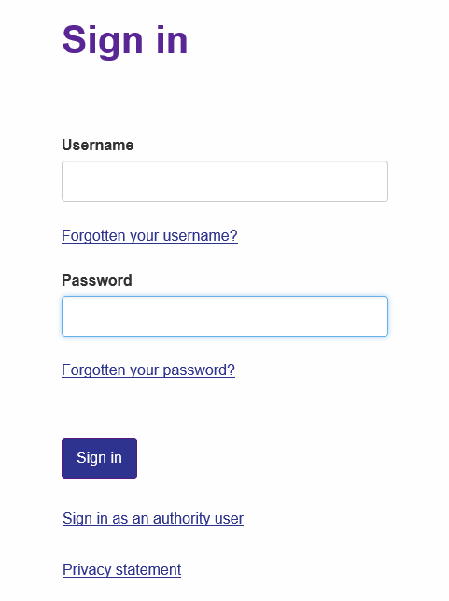

When signing in, if the details entered are incorrect then the sign in fails and you are asked to try again. You have three attempts to sign in correctly, after which, your account will be locked for five minutes. If you are still unsuccessful in signing in, please use the Forgotten Username or Forgotten Password link to reset your details.

Once you have logged in to Citizen Access Landlords, you will be taken to the Dashboard page.
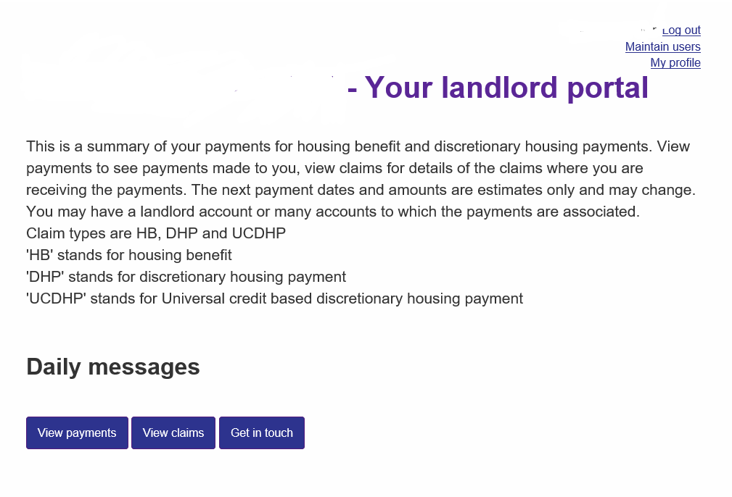

3.3 Logging out
To log out of Citizen Access Landlords, please click the link in the top right-hand corner of your Dashboard. Please note that if you are inactive for more than 30 minutes, you will be automatically logged out and will be required to start a new session.

4. Using Citizen Access Landlords

In the top right-hand corner of your Dashboard screen, you will have the option to maintain users and edit your profile.

Maintain Users
Under Maintain Users, you will have the option to create, delete or edit a user’s account. Setting up additional users will give access to another person for them to be able to view and amend details of your landlord portal.
When maintaining users, you will be required to set them up using their own email address and giving them their own username.

If you wish a new user to be able to create further users themselves, you must select ‘Make user administrator’ when creating this user.
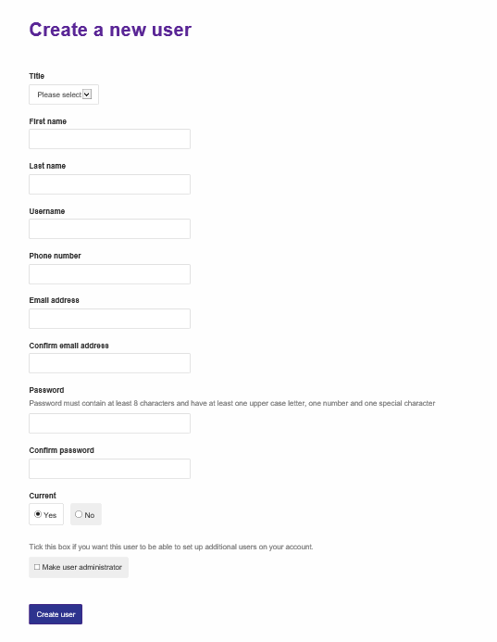

It is recommended that if you no longer wish another user to have access to your landlord portal on a permanent basis, you select the ‘edit user’ option and ‘permanently delete this user.’
If you want wish to restrict a user’s access temporarily, you can do so by selecting the ‘edit user’ option and choosing ‘Current – No’ or ‘Lock – Yes’.

4.2 My Profile
This option allows you to view the current contact details being used for your account, and you can amend or update these if required.
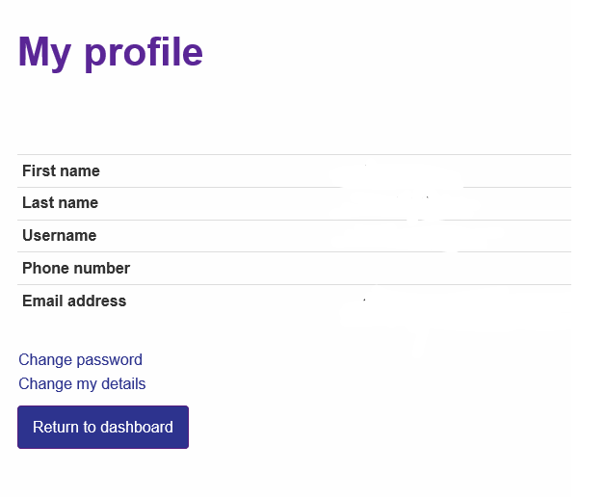

4.3 View Payments
The View Payments page enables you to search for and see details of payments made to you and how the amounts were arrived at.
To do this, click the View Payments button from your Dashboard. This takes you to the Your Payments page where you can view the details of your latest payments.

From here, you can export the payment information to a spreadsheet or print payment results. If you wish to search for a particular payment, you can enter a date range to narrow your search for payments from a specific date.
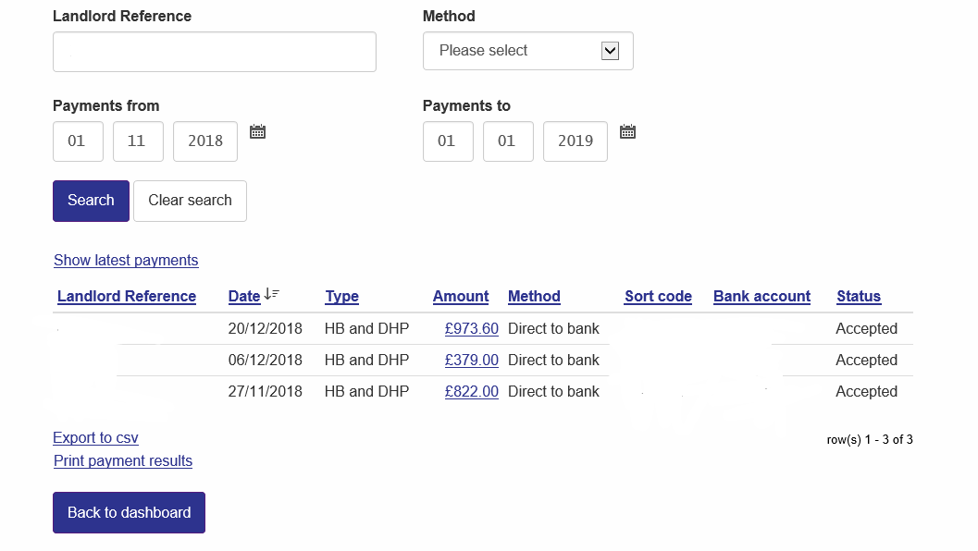

The Status column within your payment information may show different statuses depending on the processing stage. It may show the payment as Paid when the payment run is in process, however it will then show as Accepted when the payment run is completed, although it may take several days for the payment to appear in your account.

In order see a breakdown of how each payment is made up, click on the amount of the payment you wish to view. This will give you a list of the tenants included in the payment, and the amount of Housing Benefit and or Discretionary Housing Payment for each tenant.

Under the Adjustment column, it will show you whether any overpayment amount has been deducted from this tenant’s Housing Benefit entitlement within this payment. The gross weekly entitlement shows under the HB column, the Adjustment column shows how much has been deducted for overpayment recovery and the Amount column shows the net amount paid to you.
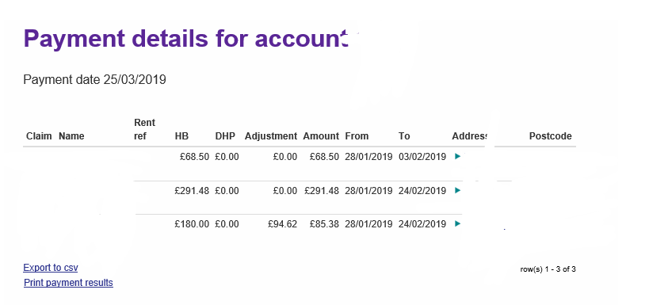

From here, you are also able to export or print a spreadsheet of this information for your records.
4.4 View claims
In order to view information relating to individual tenants, click the View Claims button from your Dashboard. This will take you to the Your Claims search page.

Here you can use any of the designated fields to search for claim information.
Using the HB Status option, you can search for claims with the following statuses:
Active – this is where a claim is currently live, and Housing Benefit is in payment
Registered – this is where a claim is waiting to be processed, and therefore payments will made until it becomes Active
Cancelled and Expired – this is where a claim is no longer active, however there could still be a final Housing Benefit payment due if the claim has only recently been cancelled.

The Current box option is automatically selected for your search. This means that only claims which are currently in payment will be shown. If you wish to view details of claims which are no longer in payment to you, such as if the tenant has moved address, or their claim is now closed, you need to deselect the Current option and select the Cancelled option under HB status. Please note that you will only be able to view details of previous payments for any cancelled claims, not details of their current entitlement or address.
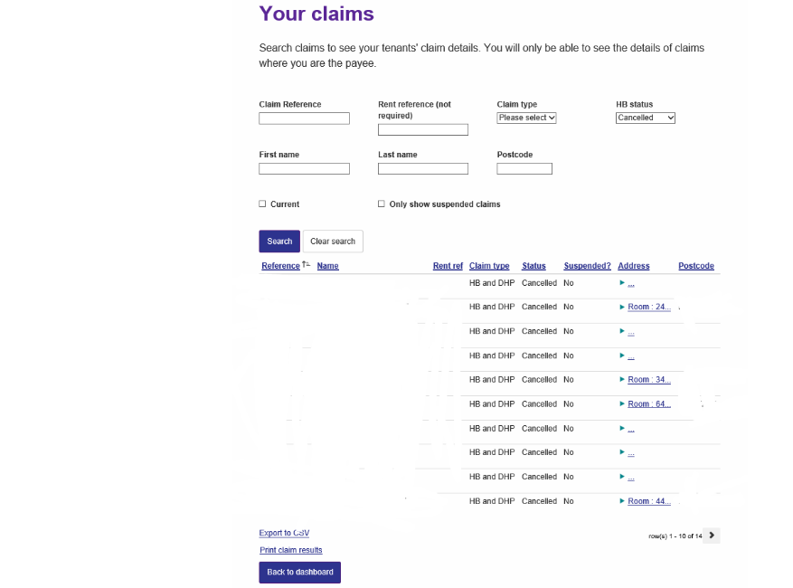

If you wish to view all claims where payments are currently suspended to yourself, please select the Only show suspended claims box.
Once you have done a search, click on the claim reference number you require. This will take you to the Claim details for that particular claim.
It will show various details including Housing Benefit weekly entitlement and whether any Discretionary Housing Payment is currently being paid.
It will also show details of the Next payment amount, and the date that this payment is due to be made. If the payment includes an underpayment or arrears of Housing Benefit, the payment may split, and part of the payment will be made on an earlier date. By the date given on the portal, you will have been paid the total of the amount shown.
If an overpayment is being recovered from Housing Benefit entitlement, the weekly recovery rate will be shown on the Claim details page. The next payment amount will show the net figure of Housing Benefit you will receive after the overpayment recovery amount has been taken from the weekly entitlement.
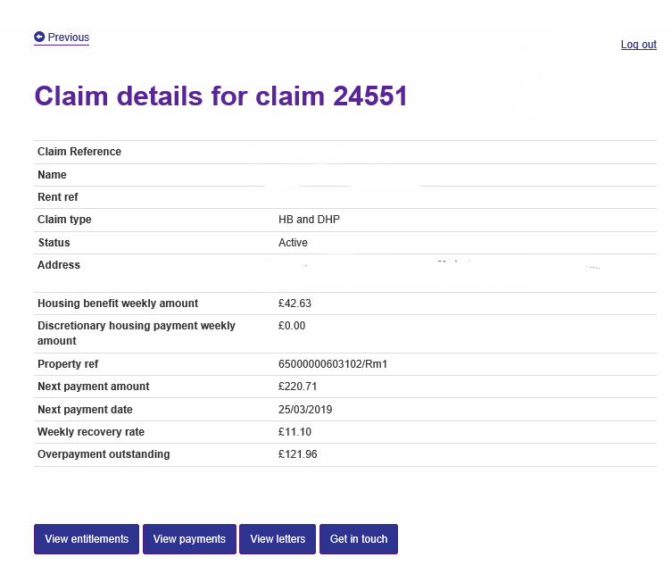
The Overpayment outstanding figure will show the total amount of overpayment outstanding for this tenant whilst they have been resident in your property. If the tenant has incurred an overpayment at a previous address, the Overpayment outstanding figure will not be visible to you, however you will still see that an overpayment is being recovered due to there being a weekly recovery.
4.5 View entitlements
At the bottom of the Claim details page, you can select the View entitlements option. This will show you the Housing Benefit entitlement details for that particular claim as well as the date that this was calculated. This information can be exported or printed in a spreadsheet format for your records.
4.6 View payments
At the bottom of the Claim details page, you can select the View payments option. This will show you all payments received for that particular tenant. This information can be exported or printed in a spreadsheet format for your records.

  - View Letters
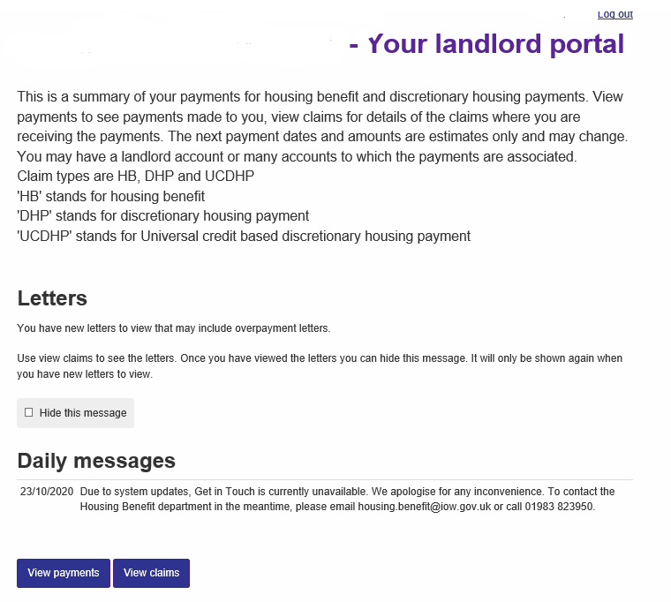
Each time you log into the portal, if there are any new notification letters for you to view, you will see a message displayed on the dashboard as below. Once you have viewed the new letters, this message will disappear, or you can hide the message yourself until the next time you log in.

To view the new letters, click the ‘View claims’ button at the bottom of the dashboard. This takes you to the ‘Your claims’ page, where you can retrieve the claims which have unread letters on them by entering the required date in the ‘Unread letters created since’ field.
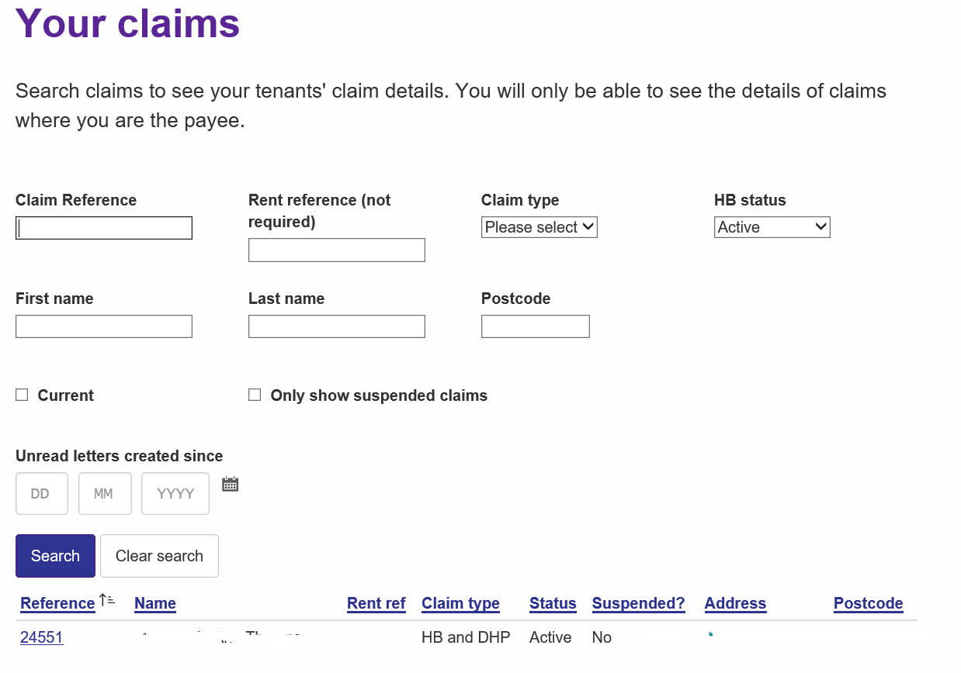

Click on the claim reference number, which will take you through to the details of that specific claim, as below. Then click on the ‘View Letters’ button at the bottom of the page.

This will show you all outstanding letters for this claim. You can click the ‘View Letter’ link which will open a PDF version of the notification letter. You can then save or print it as you wish.
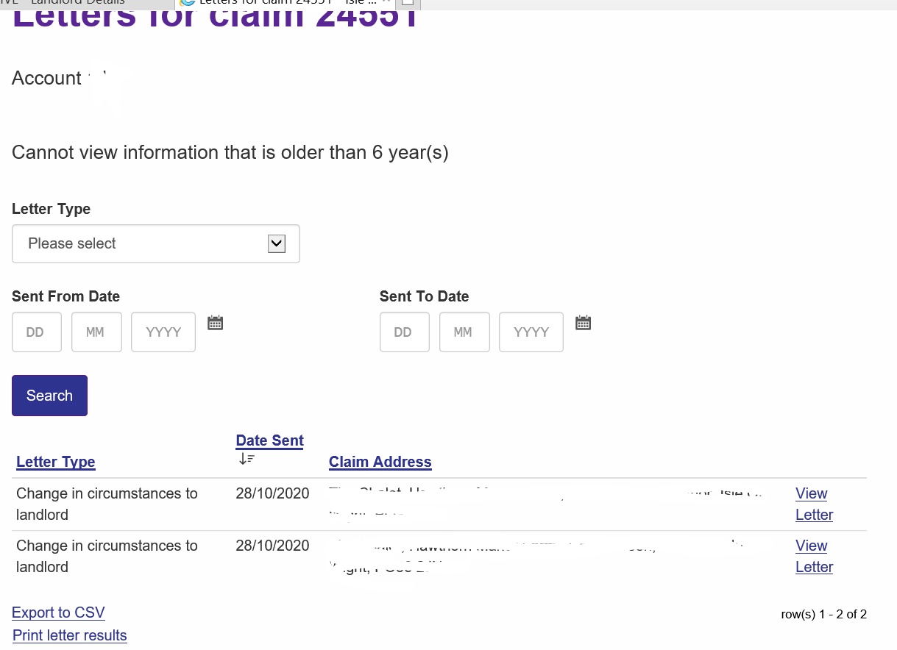

4.8 Get in Touch
This feature of the portal allows you to contact the Isle of Wight Council Housing Benefit department quickly, easily and at a time convenient to you.

There are several common options from which you can select the relevant reason for contacting us, and when selected, you will be required to enter further details regarding your contact. If you have missed any required information, when you try to submit your contact, you will receive a message which advises you to complete the section which has been missed.

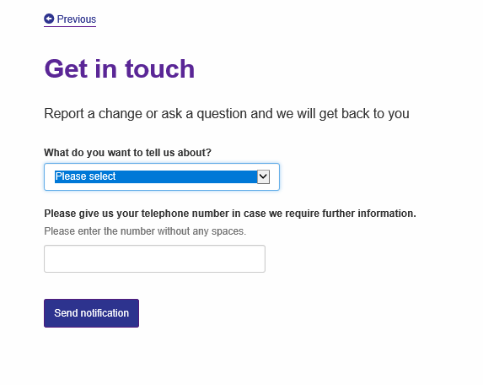

If you also wish to upload any documents, such as a proof of rent or proof of your bank details, you can do so by selecting Upload your documents. This will take you to a separate page where you can upload supporting documents as long as they meet the size and file type requirements stated.
Once your document has uploaded, you need to select Next, which will return you to the Get in Touch page. You must then scroll to the bottom of the page and select Send notification.
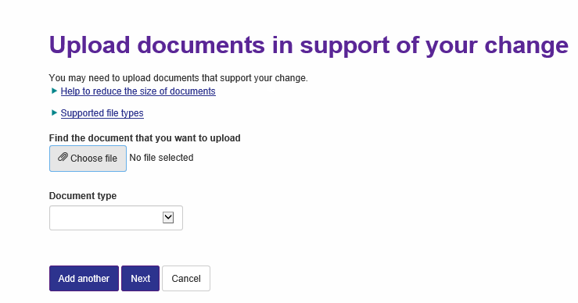

Once all sections have been completed, you must select Send notification, and if successful, you will receive a message saying Update confirmation which thanks you for your update, as well as an email confirmation showing the details of the contact you have made.
This contact will be sent directly to the Housing Benefit department to deal with and you will be notified of any outcome in due course.
