

**Bus Service Improvement Plan (BSIP)**

**December 2024 Revised version**

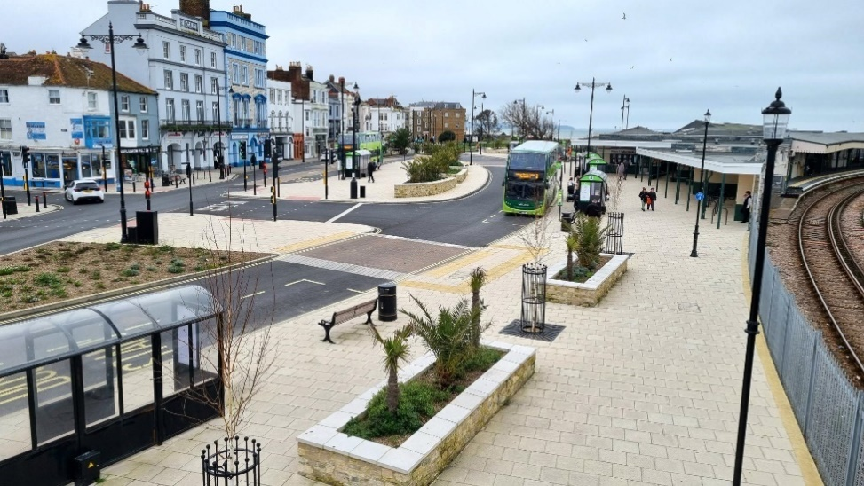

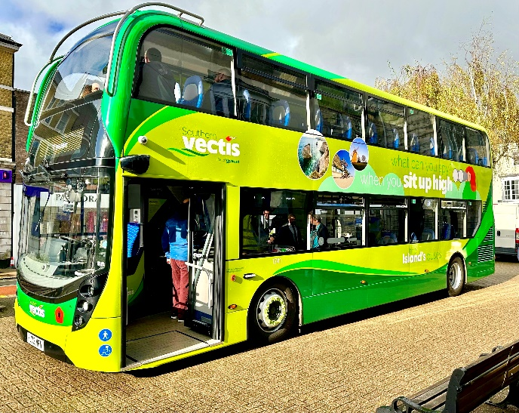

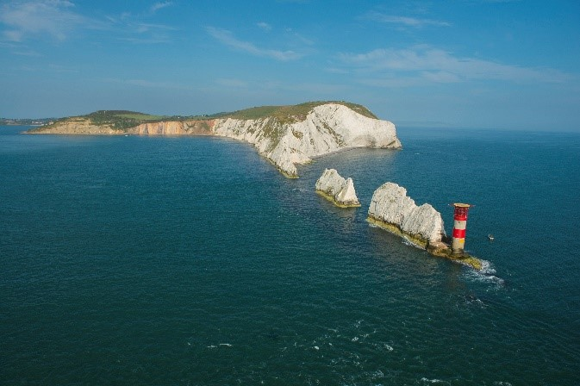

Contents

Foreword 1

Section 1 – Geographical scope and vision 3

1.1 Geographical area covered by this BSIP 3

1.2 Our Vision 3

1.3 BSIP duration, annual review process and alignment with the emerging Isle of Wight Local Transport Plan 4

1.4 Alignment with the emerging Isle of Wight Local Transport Plan 5

1.5 Alignment with other strategies and policies 6

Section 2 - Current bus offer to passengers 9

2.1 Introduction to the Isle of Wight bus network 9

2.2 Main trends in bus passenger journeys 10

2.3 Bus punctuality trends 12

2.4 Trends in bus use for work and education 13

2.5 Bus usage by visitors and tourists 13

2.6 Strengths and challenges of bus services 14

2.7 The role of ‘Connect’: community transport and carshares/car clubs on the Isle of Wight 18

2.8 Concessionary Travel 19

Section 3 – The journey so far: main bus improvements delivered since BSIP was published in October 2021 21

3.1 Bus priority and bus infrastructure improvements 21

3.2 Investment in bus fleets and local authority supported services 23

3.4 Feasibility studies 24

3.5 Publicity and marketing campaigns 25

3.6 Bus driver recruitment and retention 26

Section 4 – Programme of bus improvements for 2024/25 27

4.1 Commercial support – to aid recovery and growth on parts of the core commercial bus network that require targeted support. 27

4.2 Service enhancements on the commercial bus network 27

4.3 Improving bus stop Infrastructure and the passenger experience 28

4.4 Bus priority 28

4.5 Digital Demand Responsive Transport and measures to improve visibility of Community Transport 28

4.6 Promotional fares and marketing initiatives 29

4.7 Bus user satisfaction surveys 29

Section 5 – Our ambitions and proposals for improving bus services on Isle of Wight beyond April 2025 30

5.1 Bus network planning and improvements to bus services: service level and network coverage 30

5.2 Bus priority: delivering faster and more reliable services on priority routes/corridors 31

5.3 Improvements to fares and ticketing 32

5.4 Improvements to the bus passenger experience 33

5.5 Improvements to the bus fleet 37

5.6 Longer term transformation of the network 37

5.7 Level of funding required to deliver a better Isle of Wight bus network 38

Section 6 – EP Governance, targets and reporting and monitoring progress 41

6.1 Countywide and local targets for journey time reduction, reliability improvements and bus passenger growth 42

6.2 Specific targets for this BSIP 42

Appendix A – Background information on demography, travel patterns and bus data 46

Appendix B – Local bus market profile routes 1, 5, 9 (routes selected for upgrade to zero emission buses.) 58

Appendix C – Expenditure on supported local bus and taxi-share services 61

Table of Figures

**Figure 1– Geographical area of the Isle of Wight BSIP.** 3

**Figure 2 – Southern Vectis Bus Route network map for the Isle of Wight** 9

**Figure 3 – Bus passenger journeys on the Isle of Wight 2010-2023.** 11

**Figure 4 - Bus Passenger Journeys per head of population on Isle of Wight and Hampshire.** 12

**Figure 5 – Bus punctuality statistics (percentage) 2013-2023.** 12

**Figure 6 – Travel to work data from 2021 census (excluding those aged 15 or under or not in employment.)** 13

**Figure 7 – Modes of transport used by visitors to the Isle of Wight whilst on the island as surveyed in 2022.** 14

**Figure 8 – Concessionary pass holder usage only. 2024/25 some values are estimated.** 19

**Figure 9 - IOW vs southeast England concessionary pass journeys.** 20

**Figure 10 Results of Go South Coast Customer Satisfaction Survey for Southern Vectis, summer 2024** 29

**Figure 11 – Ferry and Hovercraft service links to the Island** 47

**Figure 12– The main towns, strategic and main A-road networks of the Isle of Wight** 49

**Figure 13 – Population Density on Isle of Wight (number of people per hectare)** 50

**Figure 14 – Health and disability deprivation (Source: H2050 – State of Economy 2020**)……………………………51

# Foreword



Phil Jordan, Leader (with responsibility for Transport and Infrastructure, Highways PFI and Transport Strategy, Strategic Oversight and External Partnerships)

Buses are a critical part of the Island’s transport infrastructure.

Our residents and my local government colleagues care a great deal about bus services on the Island. The bus industry was privatised in the 1980s, so as a Council, we do not perform a direct role in running bus services. Instead, we support and influence the commercial network as far as we can for the benefit of our residents and visitors. When the Government launched the National Bus Strategy (NBS) in 2021, it provided new opportunities to work with our commercial bus operator partner, Southern Vectis. I believe we have done so successfully, using our Bus Service Improvement Plan (BSIP) and Enhanced Partnership Plan and Scheme to strengthen our relationships with Southern Vectis, protect the network and deliver a range of NBS-funded initiatives. Passengers on the Island have benefited a great deal from the value for money offered by the DfT-funded £2 capped single fare scheme.

I am now very excited to look further to the future with this, our 2024 BSIP. I am particularly looking forward to is seeing the fleet of 22 new electric buses for Southern Vectis start to operate in 2026. The bus industry continues to face serious challenges in the form of rising costs, reduced usage and lower passenger revenue since the pandemic. Our network here on the Isle of Wight, which adapts well to accommodate large numbers of seasonal visitors every year, has not been immune to these pressures. I am very enthusiastic about the positive vision for buses that was set out in the NBS and how we translate this to the Isle of Wight. Like many Local Transport Authorities (LTAs) we are facing significant financial challenges. We want to support the Island’s bus offer as far as sustainably possible, but additional external funding that has come to us through the NBS has been and will continue to be vital in enabling us to do so.

There are some specific initiatives in the BSIP that I would like to draw your attention to:

* There will be a reduction in journey times on key routes methods such as bus priority measures at signalised junctions, and this will be achieved over the next 18 months through utilising the recent award a Department of Transport grant.
* I know financial constraints can inhibit travel. With the Government funded £2 capped single bus coming to an end, there is the scope to reduce bus fares on shorter journeys, for example on the Newport Town bus routes 37,38 and 39. The viability of a £1.50 fare for travel on town services is being considered.
* Encouragement of bus travel for under 21-year-olds by considering the viability of a £1 flat fare – this would help enhance access to both employment and leisure opportunities for young people.
* The introduction or expansion of mobility hubs at key locations, for example by the provision of e-bikes and e-scooters, to enable passengers to complete the final part of their journey.
* Improving accessibility and safety through the installation of more areas of hardstanding in rural areas, and other roadside infrastructure to improve the accessibility of a number of stops. In addition, better lighting and the additional CCTV will offer safety enhancements across the network.

All these measures and more are part of our package of further improving public transport on the Isle of Wight. Buses are vital part of Island life - for our local communities and users, and for our schools, towns, the local economy and the environment.

# Section 1 – Geograph**ical** scope and vision

## Geographical area covered by this BSIP

This Bus Service Improvement Plan (BSIP) for the Isle of Wight sets out a high-level vision for improving the Island’s bus network, including journey time and reliability targets, and our strategy and plans to deliver them. This document supersedes the Isle of Wight BSIP, approved by cabinet on 25 October 2021. This BSIP covers the single Local Transport Authority (LTA) area of the Isle of Wight (herein referred to as ‘the Island.’), the geographical area of which is shown in green in Figure 1. The **Isle of Wight Council (IWC)** is a unitary local authority covering the whole of the Island. The main bus operator on the Isle of Wight is Southern Vectis.

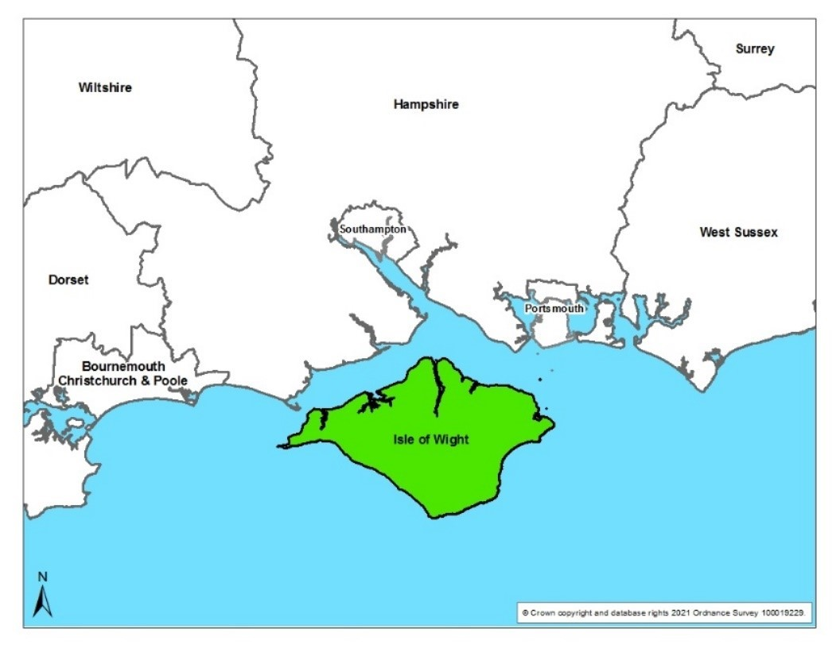

***Figure 1* – Geographical area of the Isle of Wight BSIP.**

The island covers an area of 147 square miles, with a coastline that runs for 57 miles. The Island is separated from mainland England by the Solent, but is connected to the ports of Lymington, Southampton, and Portsmouth by passenger and vehicle ferries. It is the largest and second-most populous island in England with a population of 141,538 residents.

## Our Vision

The Isle of Wight Council’s vision for future transport as set out within the draft Island Transport Plan (Local Transport Plan 4) is for:

‘An inclusive transport system that enables a low carbon, safe, prosperous, and healthy future for all residents and visitors; and seeks to protect and enhance the Island’s unique local natural and built environment.’

The Isle of Wight Council and Southern Vectis have a shared vision for improving bus services on the Island:

**“Within the Isle of Wight, both organisations recognise that local bus services are, and will remain to be, central to sustainable transport provision on the Island.  The Bus Service Improvement Plan (BSIP) represents a once in a generation opportunity for the Isle of Wight Council to work in partnership with Southern Vectis, and other community operators, to shape local provision to meet the needs of Island residents and visitors into the future. Through partnership working and ongoing joint investment, the BSIP will enable passenger growth to meet the future needs of Island, whilst addressing emerging challenges including the reductions in greenhouse gases to achieve the Island’s climate change objectives”.**

The 2021 BSIP for the Island set out the following ambitions for local bus services:

(a) Deliver intensive services and investment on key corridors, with routes that are easier to understand.

(b) There must be significant increases in bus priority.

(c) Fares must be lower and simpler.

(d) There must be seamless, integrated local ticketing across all types of public transport on the Island.

(e) Service patterns must be integrated with other modes.

(f) The local bus network is presented as a single system that works together, with clear passenger information.

(g) Modern buses and decarbonisation

(h) Give bus passengers more of a voice and support measures to ensure that bus services are perceived to be safe by all.

(i) More demand-responsive services and ‘socially necessary’ transport

(j) Longer term transformation of networks through Bus Rapid Transit and other measures

## BSIP duration, annual review process and alignment with the emerging Isle of Wight Local Transport Plan

The Isle of Wight BSIP covers the period up until 31 March 2040 (in line with the emerging LTP4 review date) and will be reviewed annually. The review will form part of the Island’s Enhanced Partnership Board and Forum annual review process. Collective decisions will be taken as to whether the level of ambition needs to be raised or whether the existing content is sufficient. Neighbouring LTAs will have an opportunity to also contribute their views. If revisions are proposed to the BSIP by the working group, then a report will be taken to IWC’s Cabinet in either October or November for political decision and sign-off on the revisions legal services advise that this is required.

## Alignment with the emerging Isle of Wight Local Transport Plan

This BSIP is fully aligned with the emerging Isle of Wight Local Transport Plan 4 known as our “Island Transport Plan” (ITP)which will form the primary transport strategy for the Island until 2040. The ITP strategy will include a goal of reducing car dependency through improving sustainable transport options, and the plans set out in this BSIP to increase the level of bus use will play an important part in achieving this goal. Please see following summary of policies within the emerging ITP that cover points within this BSIP. Sections within the BSIP are provided in bracketsagainst each point raised, where relevant, for cross referencing purposes.

Policy AS2 - Public Transport (Buses and Rail)

ITP Policy AS2 ties this Bus Service Improvement Plan (BSIP) to the emerging plan. AS2 aims to enhance bus services by simplifying fares, improving service frequencies, and enhancing customer experience.

Infrastructure Improvements: Focus on improving bus shelters, particularly in rural areas, and ensuring bus stops are well-maintained and lit for safety (see section 3.1).

Zero Emission Buses: Introduction of electric buses on key routes through the Zero Emission Bus Regional Areas (ZEBRA) funding (see section 4.2).

Mobility Hubs: Development of hubs to improve connectivity and support active travel, including the Ryde Transport Hub project (see section 3.1).

Digital Demand Responsive Transport (DDRT): Trial of a flexible shared transport system that operates based on demand rather than fixed routes and schedules (see Section 4.5)

Real-Time Information: Implementation of real-time journey information at key locations to improve the user experience (see section 5.4).

Policy AS3 - Cross-Solent Travel

Policy AS3 details transport links between the Island and mainland, including integration with bus services, enhancing connections between ferry terminals and bus services to improve accessibility and encourage sustainable travel (see section 5.6).

Policy AS4 – Transport Safety and Security

Policy AS4 includes creating safer travelling environments through measures such as lighting and CCTV (see section 5.4).

Policy BC1 - Behaviour Change

Promotion and Engagement: Initiatives to encourage bus usage through personalised travel planning, school travel plans, and public campaigns (see section 3.5).

Policy I1 - Demand Management for Car-based Travel

Parking Strategy: Adjustments to parking supply and pricing will make bus travel more attractive compared to driving.

Policy I5 - Asset Management and Climate Change Network Resilience

Bus Priority Measures: Securing funding for bus priority at signalised junctions to improve bus journey times and reliability (see section 4.4).

Policy ST1 - Sustainable Tourism

Tourism Campaigns: Promoting bus travel as a sustainable option for tourists visiting the Isle of Wight (see section 3.5).

Policy T1 - Digital Connectivity

Mobility as a Service (MaaS): Developing a framework to integrate bus services with other modes of transport into a single e-ticket and journey planning app (see section 3.5) .

These policies within the ITP reflect the content of this BSIP that aims to improve the quality, accessibility, and sustainability of bus services on the Isle of Wight, encouraging more residents and visitors to use public transport.

## Alignment with other strategies and policies

**Isle of Wight Corporate plan 2021 to 2025[1].**

One of the three key areas for action is responding to climate change and enhancing the biosphere (in 2019 the Island became a UNESCO Biosphere Reserve, which celebrated that the Island’s people and natural environment coexist harmoniously.) The council has targets to be net-carbon zero as a council by 2030, across the school estate by 2035 and as an Island by 2040.

The Cabinet Member for Highways PFI, Transport and Infrastructure states: “Enabling all modes of transport connectivity both to and around the Island is extremely important to support our plans for the sustainable future and prosperity of Island residents, and in attracting visitors and future investment.”

The Corporate plan included commitment to continue to work with the transport infrastructure board to improve infrastructure, public transport and mainland connectivity with a key activity to “adopt and implement an enhanced bus partnership with bus operators by March 2022 which has now been completed (please see Section 6). Bids for grant funding to improve bus services on the Island from a £3 billion government grant scheme will follow the BEP.”

**Isle of Wight Draft Planning Strategy, July 2021[2]**

The draft planning strategy for the Isle of Wight encompasses several key areas that align closely with the objectives of this Bus Service Improvement Plan (BSIP). These areas include:

* The need for accessible public transport links such as bus stops within walking distance from people’s homes (section 5.26 of the draft planning strategy)
* Seeking funding opportunities to support the upfront delivery of infrastructure for other locations, including for example, the provision of a park and ride scheme on Fairlee Road, Newport (section 9.10 of the draft planning strategy)
* Policy to retain and enhance existing bus and rail interchange facilities wherever possible, including full support for the Ryde interchange project (section 9.27 of the draft planning strategy)
* Promotion of sustainable transport and recognition that high quality connections by road, rail, bus, ferry, walking and cycling and their interconnectivity are all vital to the Island’s future economic prosperity and social inclusiveness (section 9.5 of the draft planning strategy)

**Mission Zero Climate and Environment Strategy 2021-2040[3]**

This strategy document published in 2021 commits the Isle of Wight to be carbon neutral by 2040. The strategy includes a number of objectives directly related to transport, a key item for this BSIP is objective 3B that public transport should make up an increased proportion of all journeys on the Island by 2040 (precise targets TBC Outputs contained within objective 3B include:

* Bus priority schemes introduced around the island to encourage 20%more bus journeys by 2040 (output 033.) See section 4.4 .
* Increase frequency of bus links in rural areas to encourage 25% more bus journeys from rural locations by 2040 (output 034. ) See Section 5 .
* Bus ticket prices are affordable for all Island residents (output 035)

The strategy includes other objectives that have outputs relating to public transport such as:

* Number of tourists travelling by bus around the Island to increase from 11% in 2017 to 20% by 2040 (output 045 from objective 3F to promote sustainable tourism to all Island visitors, with a focus on how tourists travel to and around the Island). See section 3.5.
* Bicycle racks to be included on buses along rural bus routes (output 030 from objective 3A that at least 20% of Island journeys to take place by cycling and walking[4].) See section 5.4 .

**Draft Transport Strategy for the South East, December 2024.**

Transport for South East’s draft strategy was published as this BSIP was being finalised. Some points of relevance are summarised here.

Inclusive Infrastructure and Services:

* Designing Inclusive Infrastructure: The strategy emphasises designing transport infrastructure to better serve socially excluded groups, including those with disabilities and limited mobility. This includes improved wayfinding, better lighting, and more accessible public spaces (see section 5.4).
* Upgrading Interchanges and Step-Free Access: Enhancing connectivity and comfort at transport hubs with better signage, seating, and sheltered waiting areas (see section 5.4).

Fares, Ticketing, and Service Priorities:

* Affordable Fares and Concessions: Offering affordable fares and concession schemes to make public transport more accessible to low-income individuals, students, the elderly, and other vulnerable groups (see section 5.3).
* Integrated Fares and Ticketing Systems: Implementing systems that allow passengers to travel across local government boundaries using a single ticket or fare structure, simplifying journeys and reducing costs (see section 3.5).

Service Enhancements:

* Socially Necessary Public Transport Services: Providing demand-responsive transport, rural bus services, and other options that connect isolated communities to the broader network (see section 4.5 ).
* Bus Service Improvement Plans (BSIPs): Delivering BSIPs and exploring models like franchising to improve the quality and reliability of bus services.

Specific Initiatives for the Isle of Wight:

* Ferry Services: Enhancing ferry services, including discounted fares for local residents, improved accessibility, and integrated ticketing with local bus services (see section 3.5).
* Mass Transit and Connections: Developing mass transit options and improving connections on the island, including better alignment of bus schedules with ferry timetables and investment in interchange facilities like the Ryde Transport Hub (see sections 3.1 and 5.4).

Sustainable and Integrated Transport:

* Active Travel Infrastructure: Expanding cycling and walking routes to support active travel and reduce reliance on private vehicles for short trips (see section 5.4).
* Zero-Emission Vehicle Fleets: Supporting local bus operators in transitioning to zero-emission vehicle fleets, including financial and technical assistance for replacing diesel-powered buses with electric or hydrogen alternatives (see section 4.2).

# Section 2 - Current bus offer to passengers

In this section, a selected range of key facts and insights about the bus network on the Isle of Wight are presented including;

* the extent of the commercial and supported bus networks and community transport services,
* recent trends in passenger numbers,
* bus punctuality,
* accessibility to services, and
* the number of journeys made using concessionary travel passes.

More detailed statistics and data on demographics, trends in bus use, supported bus services and the age and nature of the bus fleet can be found in Appendix A. Details about travel, bus networks, planned development and car parking costs for each local bus market area are set out within Appendix B.

## 2.1 Introduction to the Isle of Wight bus network

As an island with no physical connection to the mainland, all bus routes start and finish within the same Local Transport Authority (LTA) boundary. There are no interconnecting commercial bus operators or hard borders with neighbouring LTAs.

There are six ferry crossing points operated by three different providers for onward transport links to the mainland, that connect onward to Hampshire, Portsmouth and Southampton LTAs. There is a sole commercial railway operated by Island Line that runs for 13.7km between Ryde Pier Head and Shanklin, serving Smallbrook Junction, Brading, Sandown and Lake stations.



**Figure 2 – Southern Vectis Bus Route network map for the Isle of Wight**

The island has a sole commercial local bus operator, Southern Vectis, who are part of the wider Go-Ahead group. Considering the rural nature of the island and mix of bus demand (i.e. peak tourism seasons and regular term-time education and all-year round commuter and shopping journeys) Southern Vectis services offers a good provision for the Island, with links to all the ferry and rail services. Southern Vectis operate a fully commercial service which operates 365 days of the year. The bus fleet is currently composed of 68 double decker buses, 12 midi buses and 6 open top buses.

Being an Island network means that bus journeys are not necessarily long in nature, and are more destination focussed (e.g. ferry connections).

Newport is the geographical central hub of the Island’s bus network and there is a a hub and spoke operation, where the bus interchange accommodates the majority of bus service connections. Newport is by far the biggest employment centre on the Island, with 18,332 jobs as of 2016. The other three large centres of the Ryde, Cowes and Sandown/Shanklin have between 6,000 and 7,000 jobs each.

The most urban parts of the Island, with greater population density, are the main towns of Newport, Ryde and Cowes (East and West), with Sandown, Lake and Shanklin linking together down the east coast to form ‘The Bay’ area, almost meeting with Ventnor as the coastline sweeps towards the southernmost tip of the Island.

Levels of bus use on the Southern Vectis network are highest on route 9 (Newport to Ryde) as well as routes 2 and 3 connecting Ventnor, Ryde, Sandown and Shanklin to Newport. The quality of bus services on these main corridors is high; they offer attractive high service frequencies, with buses running every 10-15 minutes on the busiest routes (with 2-3 buses per hour on most other routes).

Currently there are a small number of community bus services in operation. FYT Bus is a charity run Community Bus project, which operates exclusively within the West Wight, run by volunteer drivers. Minibus Plus run the Service 31 runs between Bonchurch and St. Lawrence via Ventnor. It isa local town service in partnership with Ventnor Town Council. Additionally, there are a small number of community bus services operated by the Community Bus Partnership, who utilise some of Southern Vectis’ vehicles fleet, when they are not being used for home to school journeys, to operate local community services, driven by volunteer drivers.

Bus services and usage on the Isle of Wight are slightly below the national average but given the island setting with a limited road network, usage is considered good for a large, predominantly rural local transport authority, with average levels of car ownership. Bus passengers make a substantial contribution towards the Isle of Wight economy, being the most heavily used form of public transport on the Island and a lifeline for those without an alternative. The only other public transport service available is the Island Line railway that runs down the east coast between Ryde and Shanklin.

## 2.2 Main trends in bus passenger journeys

Whilst the Covid-19 pandemic did result in a significant fall in patronage on local bus services, over recent years, passenger numbers on the Island, as a whole, have recovered well, indicating a good level of resilience. As of June 2024, commercial patronage is at around 100% of pre-pandemic levels and there has been excellent performance of leisure travel, in excess of 2019 levels during the recent summer tourist season. Concessionary travel, as with many other LTA areas in England is still below pre-pandemic levels and is currently at around 85-87% of 2019 levels.

Throughout the pandemic and the intervening years, efforts have been made using financial support available to ensure that the local bus network was maintained, with close to 100% of pre-pandemic service miles currently being operated.

As shown in Figure 3, in 2022/2023 there were over 7 million bus passenger journeys, compared to 3.1 million journeys in 2021. This represents a recovery of a significant proportion of the gap between pre and post covid passenger journey levels.

**Figure 3 – Bus passenger journeys on the Isle of Wight 2010-2023[5].**

**Trends in bus journeys per head of population**

As shown in Figure 4 overleaf, in 2023 residents of the Island made 50 bus passenger journeys a year per head of population. In comparison, neighbouring Hampshire figures equated to less than 15 bus journeys per year.

Bus passenger journeys per head of population in 2022/23 is only slightly lower than in 19/20.Taken together with the trend shown in Figure 3, this is evidence of the post-covid recovery of bus services on the island.

**Figure 4 - Bus Passenger Journeys per head of population on Isle of Wight and Hampshire.**

## 2.3 Bus punctuality trends

In 2023, the Isle of Wight’s buses were the most punctual recorded in Southeast England with 89% punctuality. Figure 5 illustrates that in the ten-year period up until 2023, the Isle of Wight’s bus services have been consistently reliable, not dropping below 86% and comparing favourably with neighbouring authorities. Bus punctuality improved significantly as a result of reduced traffic during the covid pandemic (20/21) before returning to pre-covid levels in 22/23.

**Figure 5 – Bus punctuality statistics (percentage) 2013-2023[6].**

## 2.4 Trends in bus use for work and education

The key source of current travel to work data is from the 2021 census and therefore conducted during the Covid-19 pandemic national lockdowns. This information therefore needs to be considered within this context. Figure 6 illustrates 2021 Travel to Work data and showed that bus, minibus or coach accounted for a 4% modal share, with driving a car or van (51%,) working at or from home (21%) and travelling on foot (13%) accounting for the largest shares. Compared to the 2011[7] census data, bus usage for travel to work is slightly reduced in number (2582 people in 2011 compared to 2291 in 2021) but a percentage share of 4% has been maintained. The impact of the covid pandemic on travel habits of commuters on the island therefore did not impact bus usage as significantly as might be expected. The much-increased numbers of those working at or from home rose from 3,923 in 2011 compared to 12,922 in 2021. Other modes of travel were impacted more significantly on the island such as rail usage dropping from 936 to 291.

**Figure 6 – Travel to work data from 2021 census**[8] **(excluding those aged 15 or under or not in employment.)**

## 2.5 Bus usage by visitors and tourists

Figure 7 shows the results of surveys as reported by Visit Isle of Wight for modal share for visitors to the island in 2022. Bus and train were the second most used forms of transport. The bus network allows visitors to visit the island without bringing a car. Tourism is therefore a vital contributor of revenue for the Isle of Wight’s public bus network.

As well as standard services, Southern Vectis also operates a series of seasonal bus services which operate under the ‘Breezer’ and ‘Coaster’ brands. There are two open-top ‘Breezer’ bus routes that operate between the months of April sand October, allowing spectacular coastal views as well as direct access to some of the most popular attractions on the Island to support the Islands tourist offer. The Needles Breezer was named winner of the 2024 Great Scenic Journeys UK Open Top Bus Cup after a social media vote.

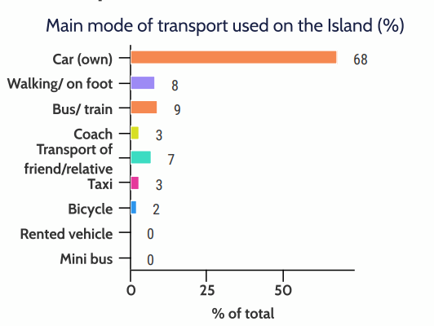

**Figure 7 – Modes of transport used by visitors to the Isle of Wight whilst on the island as surveyed in 2022[9].**

The island boasts a number of seasonal routes for visitors[10] utilising a bus fleet that includes six open top buses. Most of these routes run during the summer, but one runs at Christmas.

The Isle of Wight’s emerging LTP4 (the ITP) includes measures to persuade more visitors to leave their cars at home and use public transport through tourism awareness campaigns and ticketing options for transport services, including:

* cooperation with neighbouring authorities and public transport providers (rail/coach) to make it easier for visitors to travel without a car to the Island
* information booklets outlining key visitor destinations and how to access them using modes other than the private car

## 2.6 Strengths and challenges of bus services

The Isle of Wight’s unique geographical situation gives bus services a unique set of strengths and challenges when compared with other areas of the UK.

Southern Vectis is the island’s only commercial bus operator and due to being an island has no routes that cross another Local Transport Authority (LTA) boundary. Connections link with six ferry crossing points and the sole railway route between Ryde and Shanklin operated by Island Line.

Having one commercial bus operator means that the bus network is easier for passengers to understand, with a single Southern Vectis brand identity, reducing the complexity of marketing, branding, ticketing and pricing. The mixture of suburban style towns, rural disparate village communities, daily commuters to and from the Island, and the large number of visitors to the Island, all result in a range of transport challenges, faced Island wide. Other challenges include rural isolation, in the more remote areas of the Island, to poor air quality and congestion in parts of our towns, along with pockets of transport poverty and peak season tourist demands. Community bus operators play an important part in successful and reliable services on the Island, especially to areas where regular bus service provision has declined in the past or doesn’t exist.

It has been identified that bus infrastructure requires development in some areas. Currently no Real-Time Passenger Information (RTPI) displays are in operation on the Island, with bus users needing to use the Southern Vectis app for service updates. Another priority is improving accessibility of rural bus stops with a programme of improvements underway to rectify this so that there are dedicated, and safe waiting areas for passengers. There are road space constraints that limit the ability to deliver dedicated bus priority schemes and bus lanes, these also impact current services due to limiting vehicle movements.

Increased extreme weather events as a result of climate change poses a significant challenge to the physical integrity of the island. A large landslip in Bonchurch in December 2023 caused significant difficulties when a section of coastline dropped between 12 and 21 metres, which has led to one of the arterial routes being severed, requiring main bus services to the local towns to operate on lengthy diversions. Likewise Military Road which is a vital route running along the Island’s south-west coast, used by both local and tourist bus services, is facing multiple challenges due to increased coastal erosion, and may collapse into the sea within two years[11].

Please see the following Table (1) for an overview of strengths and weaknesses of bus services.

**Table 1 – strengths and weaknesses of the current Isle of Wight bus network.**

|  |  |  |
| --- | --- | --- |
| **Aspect of bus service provision** | **Strengths** | **Weaknesses** |
| Bus (network) | * A strong core bus network of frequent and direct services connecting town centres to majority of suburban areas within the main towns. * Being an Island, the bus network centres on the main interchange of Newport and Ryde (for rail connections) meaning most key corridors have excellent and direct bus frequencies, in particular to all ferry terminals, including first and last ferry connections, as well as other key destinations and attractions on the Island. * Historic and sustained growth in bus patronage on flagship and high frequency bus routes. * High user journey satisfaction * A modern, distinguished and attractive bus fleet on the Island with low emissions, contactless payments and charging points. | * Network predominantly operates on shared road space. Congestion at peak times, especially within peak tourist seasons, effecting key road corridors to/from centres of main towns and attractions, leads to reduced punctuality and travel time reliability, and increased journey times. * Pockets of inaccessibility in rural areas of the Island, due to lack of bus services or penetration of services, in particular West Wight. * Limited service frequency to some areas e.g. West Wight. * Limited cross Island bus services, meaning a greater need to interchange between different services in Newport for journeys across the Island. * A need to improve bus stop infrastructure across the Island with Real Time Information, Audio-Visual displays and general improvements to bus stops (i.e. in terms of accessibility, safety and comfort). * Risk of continuing landslips impacting bus routes with limited options for alternative routing. |
| Bus Network (operators) | * Strong operator brand and recognition with users across the Island. * Reduced requirements for multi-operator branding/ticketing/pricing solutions. * Smaller operators (community services) active and engaged. | * Reduction in support for less viable bus service routes on the Island. |
| Bus Network (development) | * Ongoing evolution and development of the network, reacting to need (tourism market as example). | * Locating future residential development close to bus corridors is vital. * A number of isolated traffic signal junctions cause delay to buses during peak hours, there could be a provision of selected vehicle detection signals. * Establish where bus priority is needed. Several areas with issues that effect bus services have already been identified. * Need to improve reliability and frequencies. |
| Bus Network (Town Centres) | * Well served town centres, with vast majority of bus route serving these. * Elements of bus priority and bus lanes leading to town centres. * Bus only streets in the town centres. | * Restricted and shared road space. * Limited capacity/space for terminating services to layover. * Existing infrastructure difficult to negotiate for buses. |
| Bus Network (Park and Ride) | * Limited but well used Park and Ride for Cowes to compliment Red Jet passenger services. | * Existing Park and Ride site quite small with little scope for expansion. * No definitive plans for any new Park and Ride sites for the Island. |
| Socially necessary DRT and Community Transport provision | * Active and supported community transport services, including community minibus and voluntary car share schemes. * Good supply of taxis and private hire vehicles in main urban areas. | * Scope and supply of service can potentially be limited by funding. |
| Bus-Bus, Bus-Rail and Bus-Ferry Interchange | * All public transport modes accessible from town centres. * At the Ryde Interchange the rail station is a key point of interchange, connecting the train network to the local bus network with good waiting facilities. * Ryde Transport Interchange scheme, funded via successful bid to the Government's Transforming Cities Fund (TCF) has provided a safe walking route along Ryde Pier, separate from vehicles, and create an improved transport hub for a major gateway to the Island. * Likewise other multi-modal interchange opportunities at other ferry terminals. * South Western Railway has submitted a plan to the Department for Transport resulting in an upgrade to the Island Line. | * Limited high-quality interchange hubs, with facilities, apart from at some bus stations and key rail stations. * Little co-ordination of timings between modes at key interchanges. |
| Multi-operator and multi-modal Ticketing | * Rover tickets - for unlimited travel across Southern Vectis network for 24 hours. * Rover and Breezer tickets offer 24 or 48 hour unlimited bus travel across the Island. * Multi-Day ticket bundles - for occasional travellers available in 5, 15 and 30 day bundles giving unlimited travel across Southern Vectis network including open-top and seasonal routes. Days do not have to be used consecutively and are valid for two years from purchase. * Nightrider tickets - for unlimited travel between 7pm and 7am. * Through tickets - through fares are available to any point across the Island but must be used within 3 hours of purchase. | * Little joint ticketing with ferries or rail. * Perception of poor value for money (Bus Passenger Survey – autumn 2019) – although the £2 capped single fare running until 31 December 2024 is likely to have changed this view subsequently. |
| Partnership and Investment | * Good partnership working, showcased by very effective voluntary partnerships between operators and local authority and successful bids to central Government. * Sustained investment and development of the network from operators. * Commercial bus patronage is at around 100% of pre-pandemic levels and there has been excellent performance of leisure travel, in excess of 2019 levels during the recent summer tourist season | * Covid-19 pandemic has resulted in concessionary fare passenger numbers being at 85% of pre-pandemic numbers (see section 2.8), which are likely to take time to recover. This reduction in revenue will affect ability to invest in fleet replacement and decarbonisation. * Limited spend on bus infrastructure in the past. * Poor provision of bus shelters – investment for stops and shelters needed. E.g. scope for RTPI, accessibility improvements, bring up to standards on mainland. * Bus interchange improvements required. |

## 2.7 The role of ‘Connect’: community transport and carshares/car clubs on the Isle of Wight

IWC also recognises the important role that the smaller community bus operators play in helping to build successful and reliable services on the Island. This is especially important for areas where regular bus service provision has declined in the past or doesn’t exist.

The IWC has a good history of effective voluntary partnership working with Southern Vectis, and community bus operators, on the Island. This approach has worked well for IWC, delivering sustained improvements for bus users over more than a decade.

Currently on the island there are:

* FYT Bus (charity run Community Bus) operate a Dynamic Demand Responsive Transport (DDRT) service within West Wight using electric vehicles.
* Service 31 operated by Minibus Plus in partnership with Ventnor Town Council running between Bonchurch and St. Lawrence via Ventnor.
* Smaller community bus services operated by the Community Bus Partnership utilising some Southern Vectis vehicles when not in commercial use.

Residents on the Island can make use of Liftshare to find others to carshare their journeys. The Isle of Wight also has two car clubs.[12] The IWC supports a car club is funded by the Department for Transport, managed by Carplus and run by Co-Wheels social enterprise. At the time of the producing this BSIP, it operates from two locations (Cross Street Car Park, Cowes and Quay Road Car Park, Ryde.) Enterprise car club also operates on the Island. Carshare services are useful in reducing the number of journeys by car, whilst car clubs can help users have access to a car without the need for car ownership. Having access to a car without the commitments of car ownership can help support people to more frequently use other means of transport, such as public transport.

## 2.8 Concessionary Travel

The English National Concessionary Travel Scheme (ENCTS) is a national scheme that enables eligible (criteria apply) older and disabled people to travel for free by bus at specific times of the day. At the time this BSIP was written, the Isle of Wight offers discretionary enhancements to the scheme. The Isle of Wight Council also offers the ‘New Island Card’ local concession for use on local bus services by Island residents. These are issued to local residents who have a severe and enduring mental health problem (Gold Card) and to those who require a travelling companion (Silver Card) to access public transport. See Appendix A for further details.

Local Authorities reimburse operators for the cost of the journeys made by individuals using their concessionary travel pass. Reimbursements are calculated in accordance with formulae intended to cover operator costs, but not operator profit. Therefore, although the ENCTS scheme and any additional enhancements help support the bus network’s costs, they are not considered commercial sales.

The total number of concessionary pass holders within the Isle of Wight (as of the 31st of March 2024) was 33,008. 28% of Isle of Wight residents are over 65 years old, compared with 24% in England and Wales and the population is ageing – there was a 20% increase in the 85+ age category between the 2001 and 2011 census. As well as high demand, a number of rural bus routes have high concessionary pass usage that helps support their commercial viability. The concessionary travel scheme is therefore of utmost importance to the Isle of Wight bus network.

Figure 8 details the trend of concessionary patronage in the last 12 years. It clearly illustrates the impact of the covid pandemic and the rate of recovery since. Concessionary passenger numbers are increasing but are still currently around 85% of pre-covid levels.

**Figure 8 – Concessionary pass holder usage only. 2024/25 some values are estimated.**

Figure 9 illustrates that the recovery of concessionary travel pass use on the Isle of Wight since the Covid pandemic has been better than the average in Southeast England.

**Figure 9 - IOW vs southeast England concessionary pass journeys.**

# Section 3 – The journey so far: main bus improvements delivered since BSIP was published in October 2021

As evidenced in Section 2, the Isle of Wight bus network has made excellent progress since the publishing of the previous BSIP in recovering passenger numbers. Some of the measures delivered (and in progress) are set out in this section.

The Isle of Wight Council has been allocated a total of £580,050 of BSIP phase 2 funding for the financial years 2023/24 and 2024/25. These have been split into two equal payments of £290,025.00, once per financial year[13]. Other funding sources for the measure delivered include the Transforming Cities Fund, Bus Recovery Grant, ZEBRA and Future Transport Zone.

## 3.1 Bus priority and bus infrastructure improvements

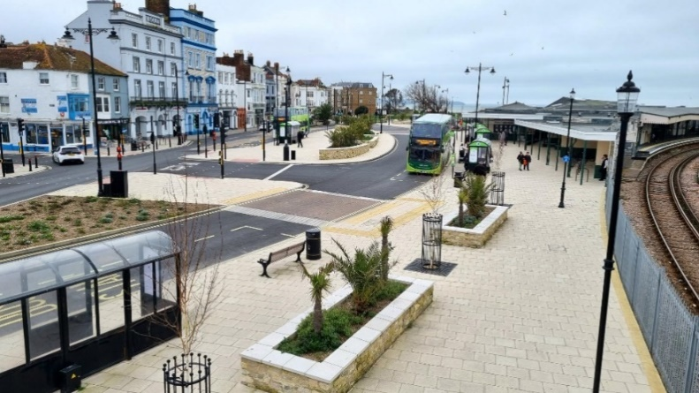

**Image 1 – Photograph of completed Ryde interchange.**

**Ryde Interchange project.**

Arguably the most significant capital improvement since the previous BSIP is the completion of the Ryde Interchange project[14]. This project provides better travel connectivity as well as much-improved public space for residents and visitors.

The project was primarily funded by Government grant from the Transforming Cities Fund, following a successful joint funding bid by the Isle of Wight, Portsmouth City and Hampshire County Councils (together as a part of the South East Hampshire Rapid Transport programme) for £55.6m. Around £10 million of this was awarded for the Ryde Interchange improvements of which the highway, bus priority and bus infrastructure work is just one element.

**Bus priority measures**

The Ryde Interchange has provided some local bus priority measures for multiple services.

Additionally, an upgrade of traffic signal heads has been completed on the Island, as part of the Highways PFI contract, that is the first step in delivering bus priority at the majority of signalised junctions. The next step will be to upgrade the traffic signal software to enable this function (see sections 4.4 and 5.2.)

**Improvements to bus stops**

* A programme of upgrades to rural bus stops is ongoing. The improvements are site specific and include the introduction of dropped kerbs, new road markings and signage, tactile paving, increased hard standings and improved drainage. These provide a more accessible place for passengers to wait, rather than (for example) having to use a grass verge or stand on the road.
* Additionally, a small number of bus stops on key routes within towns have also been improved to ensure they are accessible. This was a part of the Equality Act Project which has focused on accessibility improvements along footways along key routes.
* In the last 12 months, a number of bus shelters have been upgraded to lit shelters. This improves the waiting environment for bus users during the hours of darkness whilst improving personal safety. These upgrades were commercially funded through IWC’s bus shelter advertising contracts.

**Real time information**

Southern Vectis have developed an app that allows users to track their bus. Therefore, although the island has no Real Time Passenger Information boards installed at bus stops, residents with access to the app have a provision that can be used at any location on the island.

Additionally, within the wider Ryde Interchange project as mentioned above, each of the bus stands are due to have real time information screens installed this autumn. These will be audio and visual displays. Likewise, two mobile battery powered screens are being provided which will be trialled elsewhere on the network.

## 3.2 Investment in bus fleets and local authority supported services

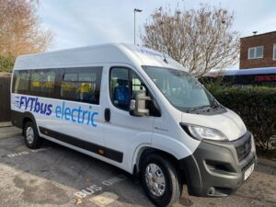

**Image 3 - FYTbus Electric Community Bus (copyright FYTbus website).**

* FYTbus launched a new route in September 2023 using a brand-new electric bus that runs between Bouldnor through Yarmouth, Freshwater and Totland and onto Alum Bay on weekday afternoons. This has been part funded by the Department for Transport (DfT) Future Transport Zone programme for the Solent sub-region.
* FYT are in the process of purchasing a further electric minibus and installing photovoltaic panels on the roof of their depot to power both buses. The new bus and the charging infrastructure required was funded using DfT Bus Recovery Grant funding, costing £60k.
* Bus Recovery Grant funding has also been used to reimburse a local community bus operator following volunteer driver shortages requiring replacement paid Southern Vectis drivers.
* BSIP phase two grant funding has been used to:
  + support the frequency of bus services on Route 5, increasing to every 15 minutes Monday to Saturday daytimes. Route 5 connects Newport with East Cowes via Whippingham and Osborne House.
  + for additional evening journeys, Mondays to Saturdays, on the Southern Vectis local bus service 6 which operates between Newport and Ventnor, serving Gatcombe, Chillerton, Chale, Niton and Whitwell.
  + for additional evening journeys, Mondays to Saturdays, on the Southern Vectis local bus service 12 which operates between Newport and Alum Bay, serving Shorwell, Brighstone, Brook, Freshwater Bay and Totland.
  + for services 6 and 12 during the winter period October to March, to ensure they continues to operate at current service levels.
* IWC working in partnership with Southern Vectis was successful in a bid for Zero Emission Bus Regional Area (ZEBRA Round 2) funding. This will see 22 new electric buses join the Southern Vectis fleet in 2026, which will be used on routes 1, 5 and 9 (see Appendix B for route profiles) and charging infrastructure is to be installed at Newport depot.
* Southern Vectis has invested £1.7m in a fleet of seven new British-built ADL Enviro 400 MMC double-decker buses which were delivered in November 2023 and now operate on route 1 between Newport and Cowes. These are ultra-low emission Euro 6 diesel buses - cleaner than the latest generation of diesel cars, helping to improve air quality. Customers are benefiting from at seat USB charging points, contactless ticketing and improved levels of comfort for passengers[15].

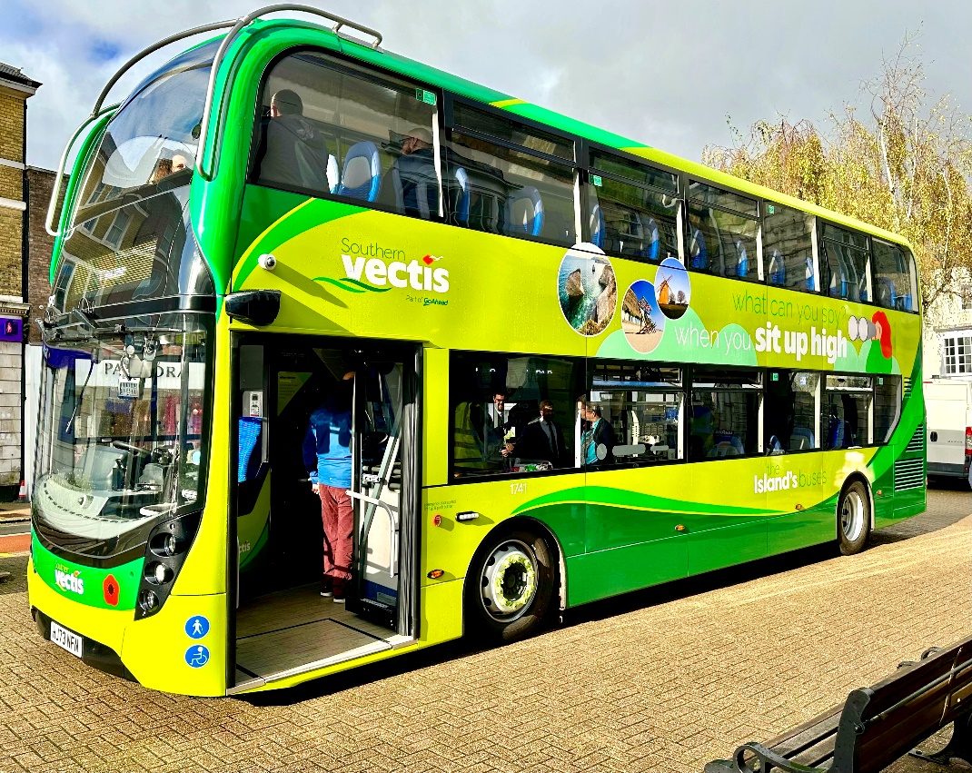

**Image 4 - One of the eight new buses for Cowes to Newport route**

## 3.4 Feasibility studies

A business case was prepared using funding from the “Restoring your Railways” feasibility study fund which considered the option of development of a new Bus Rapid Transit service on the closed railway track bed on the Isle of Wight to-establish a bus link to Ventnor. It is proposed that this would operate along the same route as the now redundant rail line from Shanklin to Ventnor via Wroxall. This would require the current shared route to be converted for use as a dedicated bus route. All current infrastructure along the route would need to be upgraded for this purpose and likewise would require some third-party land to reopen some sections of the old rail line. One major hurdle would be the reopening of the tunnel before it rejoins the highway at the old ‘Ventnor East’ rail station. As detailed in section 2.6, the Isle of Wight has recently experienced a landslide at Leeson Road, Ventnor, and there is a risk of future landslips that could impact the ability of bus services to reach their destinations along this critical route Therefore a Bus Rapid Transport service that redevelops a separate route could be a potential alternative for public transport to operate between the two towns, as well as connections for onward travel.

## 3.5 Publicity and marketing campaigns

**The Breeze app**

Breeze App

The Isle of Wight Council are members of the Solent Transport[16] Future Transport Zone. Breeze is a development of Solent Transport and is the first MaaS (Mobility-as-a-Service scheme[17]) app in the UK. It is a free travel planning and booking app that helps users find the quickest, cheapest, and most eco-friendly options for their journeys. The Breeze travel planning app covers the Solent region, including South Hampshire and the Isle of Wight, providing a single place to plan routes and buy tickets. Currently Southern Vectis, Islandline and Hover Travel are fully integrated on the app, Wightlink and Red Funnel are planned to be fully integrated (for buying tickets) at a later date.

**Southern Vectis app**

Users receive the latest service updates, plan their journey, purchase tickets, track buses and personalise their journey by adding favourite bus stops.

**£2/£3 capped fee on single journeys**

A national scheme to encourage the use of local bus services introduced the £2 capped fare on single journeys on 1st January 2023. The local commercial bus operator has advised that the outcome of has been an average increase in the region of four percent across all bus services on the Island. The cap will change to £3 from 1st January 2025.

**Southern Vectis UK Bus Operator of the year[18]**

In 2023, the island’s primary and only commercial operator was awarded the accolade of UK Bus Operator of the year at the UK Bus Awards. As well as assessing buses and drivers, the judges considered bus operators’ mobile apps, their quality of customer service and public relations. They also undertook mystery shopper journeys across bus networks.

**It’s everyone’s journey[19]**

Southern Vectis took part in the Department for Transport’s behaviour change campaign that aims to encourage all passengers to behave in ways that improve disabled passengers’ travel experience, such as giving up a disabled/priority seat when on board.

**Feedback on electric buses[20].**

Southern Vectis are carrying out an engagement exercise to help inform the type of electric buses to be purchased using the ZEBRA round 2 funding awarded in spring 2024 for 22 new buses.

**Slow Travel Guide[21]**

The [Slow Travel Guide](https://slowwighttravelguide.co.uk/) to the Isle of Wight is funded by Isle of Wight Council’s Access Fund and Visit Isle of Wight Ltd. Researched, written and curated by Mark Rowe, the guide has been written to allow exploration of the Isle of Wight by walking, cycling, or taking the bus or train. There are eight sustainable travel touring routes, each featuring bus routes.

**Visit IOW Bus Guide[22]**

The Island's Official Tourism Website has [an excellent guide](https://www.visitisleofwight.co.uk/information/product-catch-all/southern-vectis-the-islands-buses-p137661) for visitors using the Island’s bus network.

**Visit Isle of Wight**

IWC works with Visit Isle of Wight with a target to double the number of tourists travelling by bus around the Island from 11% in 2017 to 20% by 2040. We engagement with Visit Isle of Wight via our monthly Transport Infrastructure board.

**School Travel Plans**

We are currently supporting a number of schools with school travel planning through the Modeshift platform. Beyond this, and as revenue funding from Active Travel England and BSIP allows, we shall look to assist schools with a full review of their school travel plans. Through education and awareness, school travel plans allow schools to understand the benefits of using buses and so develop an enthusiasm for modal shift from car use.

## 3.6 Bus driver recruitment and retention

Southern Vectis currently has no bus driver recruitment issues and reportedly have more drivers than they need[23]. Drivers have on occasion been deployed on the mainland by the Go-Ahead group.  However, as the demand on the bus network significantly changes between peak and off-peak tourist season, Southern Vectis are often having to recruit additional seasonal drivers to ensure they maintain the operational levels required.

Community bus operators have had volunteer driver shortages post-covid pandemic.  The Bus Recovery Grant was used to pay Southern Vectis drivers to make up for these shortages.  Volunteer bus drivers have since been recruited and is not currently an issue impacting services.  It should be noted however that volunteer driver recruitment is an ongoing potential area of difficulty for community bus operators.

# Section 4 – Programme of bus improvements for 2024/25

## 4.1 Commercial support – to aid recovery and growth on parts of the core commercial bus network that require targeted support.

The Isle of Wight Council has been allocated a total of £580,050 for BSIP phase two funding for the financial years 2023/24 and 2024/25. These have been split into two equal payments of £290,025 per financial year.  
The BSIP phase 2 funding has been allocated towards:

(a) Additional journeys on services 6 and 12 (at a total cost of £91,500 per year)

(b) Increased frequency on service 5 (at a total cost of £145,025 per year)

(c) Service 6 and 12 winter funding (at a total cost of £53,500 per year)

More specifically, this BSIP phase 2 funding is being used to:

* Support the frequency of bus services on Route 5, increasing to every 15 minutes Monday to Saturday daytimes. Route 5 connects Newport with East Cowes via Whippingham and Osborne House.
* Run additional evening journeys, Mondays to Saturdays, on the Southern Vectis local bus service 6 which operates between Newport and Ventnor, serving Gatcombe, Chillerton, Chale, Niton and Whitwell.
* Run additional evening journeys, Mondays to Saturdays, on the Southern Vectis local bus service 12 which operates between Newport and Alum Bay, serving Shorwell, Brighstone, Brook, Freshwater Bay and Totland.
* Support services 6 and 12 during the winter period October to March, to ensure it continues to operate at current service levels.

Although the additional journeys and funding for services 6 and 12 have increased patronage, early indications from Southern Vectis are that funding support will be required 2025/26, albeit at a reduced rate, please see section 5.7.

## 4.2 Service enhancements on the commercial bus network

Under the Zero Emission Bus Regional Area (ZEBRA) round 2 funding, Southern Vectis will introduce 22 new electric buses to its fleet in 2026, specifically on routes 1, 5, and 9. The low-emission buses currently operating on these routes will be redistributed across the wider network, allowing for the retirement of the oldest, higher-emission vehicles. This transition to electric buses will not only reduce the overall environmental impact but also modernize the fleet, resulting in a lower average vehicle age and improved service quality across the network. Please see Appendix C for grant details.

As this BSIP was being finalised, details have emerged that in addition to the above, a further 9 electric buses are hoped to be introduced in 2026, subject to £1million ZEBRA funding.

## 4.3 Improving bus stop Infrastructure and the passenger experience

The programme of accessibility upgrades to rural bus stops is progressing well. Each improvement is being tailored to the specific needs of the site and includes features such as installing dropped kerbs for easier access, adding new road markings and signage for better visibility, incorporating tactile paving to assist visually impaired individuals, expanding hard standing areas to provide more stable surfaces, and upgrading drainage systems to prevent water accumulation. The prioritisation of locations that form part of this programme has been informed by current frequency of bus service and in relation to key locations such as schools, medical services, shops, employment etc.

Investigative trialling is underway to evaluate the installation of audio-visual Real Time Passenger Information (RTPI) displays at Ryde interchange. This trial, which spans a four-year contract period, aims to assess the effectiveness and benefits of these displays in providing passengers with up-to-date travel information.

The Breeze app will continue to be developed, with work being completed to integrate the two largest commercial ferry operators Wightlink and Red Funnel into the ticketing system, making for better onwards integration across the Solent and onto the mainland.

## 4.4 Bus priority

Much of the highway network on the island is space constrained, and currently there are no bus lanes or bus gates on the network. Instead, the focus has been on upgrading traffic signal equipment at the majority of signalised traffic junctions with the latest Selective Vehicle Detection (SVD) technology. When complete, this will allow small increases in the green signal phases for those approaches to junctions in locations that are most heavily used by local bus services. This will help to improve journey time reliability for these buses. The traffic signal heads have been upgraded and work will progress on upgrading the software to enable bus priority at the junctions. The programme of traffic signal upgrades will be completed by March 2026, with the new SVD functionality then enabling signal phasing plan changes that benefit buses to then be progressively introduced in the intervening period.

## 4.5 Digital Demand Responsive Transport and measures to improve visibility of Community Transport

Digital Demand Responsive Transport (DDRT) is a way of providing a public transport service that responds to demand, rather than following a schedule. This allows users to travel at more convenient times, whilst reducing operator costs, suiting rural communities and off-peak timings where a regular bus service would not be commercially viable.

Through the DfT funded Future Transport Zone Programme for the Solent area, FYT bus has launched a DDRT[24] service. This has involved providing a new DDRT back-office system to manage bookings, track buses and plan routes digitally, on-the-go. Users book seats[25] in the Freshwater, Yarmouth and Totland areas. The DDRT provision is due to be integrated into the Breeze app.

## 4.6 Promotional fares and marketing initiatives

The national initiative to promote the use of local bus services, which includes a £2 capped fare on single journeys, is scheduled to continue until the end of December 2024. Following this period, the scheme will transition to a £3 capped single fare. This initiative has proved to be effective in helping to make bus travel more affordable and accessible. It has encouraged more people to choose public transport for their daily commutes and other travel needs. .

Please see section 5.4 for further details on marketing initiatives.

## 4.7 Bus user satisfaction surveys

The Go-Ahead Group operate Southern Vectis as the Isle of Wight’s sole commercial bus operator on the Isle of Wight. In the summer 2024, Go South Coast completed a Customer Satisfaction Survey, which gives the best available evidence of bus user satisfaction on the Island. Results were extremely favourable, with Southern Vectis scoring 94% for overall satisfaction.

**Figure 10 Results of Go South Coast Customer Satisfaction Survey for Southern Vectis, summer 2024**

The presence of a single commercial operator on the Isle of Wight allows surveys to be interpreted across Island bus services. Although the Isle of Wight Council have an aspiration to complete a separate bus user satisfaction survey, unfortunately this has not yet been possible due to resource constraints.

# Section 5 – Our ambitions and proposals for improving bus services on Isle of Wight beyond April 2025

The Isle of Wight Council has a number of future ambitions as described in this section and detailed in Table 2. Delivery of these would be dependent on obtaining funding.

A route-by-route review is planned to commence in Spring 2025 that will consider numerous factors such as service usage rates, frequency of services and details of locations in need of improvements. The review will help inform some of the project details of some of the proposals in this section.

## 5.1 Bus network planning and improvements to bus services: service level and network coverage

The BSIP phase two funding for the financial years 2023/24 and 2024/25 (see Section 4) is being utilised to deliver service enhancements that seek to increase the number of bus journeys from rural locations in accordance with the Mission Zero Climate and Environment Strategy 2021-2040 (see 1.5) These opportunities will be pursued throughout the lifetime of this BSIP.

The Isle of Wight Council plans to work in partnership to improve integration of the bus network with other transport modes, especially cross-Solent ferry services.

We have an aspiration to increase the frequency of Newport town bus services (37, 38 and 39) from their current hourly frequency to half hourly during the day 07:30 – 18:00 and to extend the hours of operation of these town services to operate later into the evening on an hourly basis after 18:00.

A park and ride scheme is proposed on Fairlee Road, Newport. The Council will be considering the viability and need of the scheme over the next five years.

**Ryde – Yarmouth Public Transport Corridor[26]**

The Isle of Wight Council is set to receive more than £13.6 million in Levelling Up Fund funding as part of the third round of the fund to transform connectivity between East and West Wight with an improved active and sustainable travel corridor — or 'Island Green Link.'

The plans for this corridor include delivery of bus stop infrastructure improvements along the key bus routes between Ryde and Yarmouth. The sorts of interventions set to be delivered include providing accessibility ramps, new bus shelters, and real time information screens at well used bus stops.

It will also involve a small number of trial ‘mobility hubs’ to provide space and facilities for switching easily between difficult modes of transport. This could include luggage lockers as well as e-bikes and e-scooter bays at bus stops so more visitors and residents can easily enjoy nearby bridleways and cycleways.

This project will help the long-term ambition of better integrating active travel with public transport.

**The approach for Commercial routes**

The Isle of Wight Council shall continue to work with Southern Vectis on opportunities to support and enhance the existing network of commercial bus routes. This is through prioritising investment in bus stop infrastructure and bus priority measures on key corridors.

Likewise in respect of more rural services, IWC shall continue to invest in improving bus stop infrastructure and work with Southern Vectis on agreeing a design standard for all stops across the Island, for the benefit of services users, that is also sympathetic to the local environment.

Beyond this the IWC shall develop proposals for Bus Rapid Transit on the Island, which will focus on key corridors connecting the ferry ports and other key interchanges. These will take the form of island extensions to the Mass Rapid Transit corridors being established by our neighbouring mainland Local Transport Authorities.

**Supported services**

Since September 2015 the IWC has not directly funded or subsidised local bus services on the Island. Therefore, the current network of local bus services is primarily commercially operated by Southern Vectis complemented by a small number of community bus services. The only Council funding received by Southern Vectis, outside of external funding sources, is concessionary travel reimbursement.  As described in Section 2.8, the concessionary travel scheme includes discretionary enhancements and Appendix C details the current costs to IWC.

Going forwards, it is the Council’s aspiration to establish or re-establish supported services, either by traditional contracted services fully supported using available budgets or through Demand Responsive Transit (DRT). The primary focus will be for isolated rural communities who have not had a regular bus service since at least 2015.

Likewise, to support the evening economy and ensure a true viable alternative to car ownership for local journeys, another aspiration is to extend or enhance commercial services in the evenings to make bus travel a more viable choice. This would include extending bus operations into the evening and increasing frequency of local bus services within the main towns.

## 5.2 Bus priority: delivering faster and more reliable services on priority routes/corridors

As detailed in section 2.3, the Island consistently achieves high performing bus punctuality, reducing the need for more intrusive infrastructure improvements. Additionally, the ability to implement such infrastructure improvements has its own difficulties given the physical limitations of the Island's local road network, as the well as the predominant rural nature. Therefore, it does not lend itself to reallocating or widening the carriageways to enable dedicated bus lanes or similar measures.

On this basis, future improvements are being focused on implementing bus priority measures at signalised junctions on key bus routes. This is due to be achieved over the next 18 months through utilising the recent award of DfT Traffic Signal Obsolescence Grant and Green Light Fund for the Island of £265,887.00.  It is hoped that through this funding every signalised junction on the Island’s principal routes connecting the main towns, areas of employment, tourist destinations and cross-Solent ferry terminals, will have bus signal priority. Whilst each site will generate a small potential time saving per journey, it is anticipated that the combined impact of junction improvements about bus routes and the frequency of service will lead to an improvement in overall punctuality on the routes. It is planned for the work to be completed by April 2026.

Southern Vectis consistently reports that enforcement issues on the Isle of Wight are minimal, making improvements to signalised junctions a higher priority. This is due to the Isle of Wight's bus infrastructure being significantly smaller in extent compared to neighbouring mainland authorities. Should the situation change, the Isle of Wight Council will seek, or exercise enforcement powers.

## 5.3 Improvements to fares and ticketing

**Capped daily and weekly fares**

Prior to the Government funded £2 capped single bus fare being introduced, IWC was looking at the scope to reduce bus fares on shorter journeys on Town bus routes within Newport and Ryde i.e. 37, 38 and 39. The £2 capped single fare will be replaced in January 2025 with a £3 capped single fare until 31 December 2025. When the £3 capped single fare comes to an end, IWC will give further consideration to this option. The viability of a £1.50 fare for travel on town services is being considered.

We would like to be able to encourage bus travel for under 21-year-olds by considering the viability of a £1.50 capped fare for these people, following feedback that the £2 national fare cap was too high for under 21s.

Commuters already benefit from a cap on single journeys that require a bus connection and so there are no current plans to review options for commuters.

**Expanding the range of fares and ticketing products**

We have an aspiration to develop an improved ticketing offer for young people (16–24-year-olds) to help support the evening economy and for increasing longer term bus usage.

To support the local nighttime economy the viability of a £1 flat fare for Friday and Saturday evenings is being considered.

To support individuals into employment, we would like the introduction of a scheme that allows free bus travel for job seekers and new employees. Cost of access to employment can prevent longer term unemployed people from travelling to employers and free bus travel would help overcome this barrier.

We have an aspiration to offer extensions to concessionary travel on services 6 and 12 for journeys to allow pre-09:30AM travel, subject to funding.

## 5.4 Improvements to the bus passenger experience

**a) Improved bus stops, bus stations and interchanges**

We aim to enhance bus stop infrastructure at interchanges and bus stops on key priority routes. There is significant potential for mobility hubs at strategic locations and interchanges. These hubs will facilitate multimodal connectivity, linking the active travel network (including e-bike and e-scooter facilities) with public transport. Mobility hubs will include infrastructure such as shelters, CCTV, and accessibility improvements. We will develop these hubs following the Solent Transport Mobility Hub design guide[27]. Further details such as locations, quantities, timeframes and costs will be determined through the lifetime of this BSIP and informed by the route-by-route review in 2025.

Plans for proposed improvements to CCTV at bus stops will be developed following a review of the current bus infrastructure and usage. We will look to focus on current high footfall locations, where current CCTV provision could be improved or has sufficient electrical connections to enable its deployment. Work to inform this will be undertaken in collaboration of the Local Police Authority and the established Community Safety Partnership. The plans (including timescales) are to be developed through the lifetime of this BSIP.

We plan for significant improvements to be made at interchanges at Shanklin and Yarmouth. These will be similar to the work completed in Ryde, albeit on a smaller scale. The improvements at Yarmouth Junction are hoped to be delivered as part of the the Ryde – Yarmouth Public Transport Corridor project (see 5.1) whilst we intend to use BSIP 2025/26 capital funding to commission feasibility designs to help develop a business case for Shanklin. Longer term, the use of further BSIP or Integrated Transport Fund could help deliver the improvements.

The programme of accessibility upgrades to rural bus stops is ongoing. Each improvement is tailored to the specific needs of the site and includes features such as installing dropped kerbs for easier access, adding new road markings and signage for better visibility, incorporating tactile paving to assist visually impaired individuals, expanding hard standing areas to provide more stable surfaces, and upgrading drainage systems to prevent water accumulation.

The rural bus stop programme will have a route-by-route review, informed by current frequency of bus service and in relation to key locations such as schools, medical services, shops, employment. Up to twenty bus stops are to be upgraded per annum. The cost can vary from £100,000 to £1,000,000 per annum, depending on the infrastructure required (for example some may require installation of shelters, lighting, RTI, CCTV, bike racks, in addition to hard standings, accessibility improvements.)

Our Mission Zero Climate and Environment Strategy aims for installation of bicycle racks on rural bus services, something previously trialled on rural services and to be explored over the lifetime of this BSIP, alongside the proposals for increased cycle storage at mobility hubs. The proposal will be developed over the lifetime of this BSIP when bus routes, numbers of buses and costs will be determined. We hope to make use of future BSIP funding or where appropriate, section 106 contributions.

**b) Improved bus information and network identity**

IWC is looking to deliver Real Time Passenger Information (RTPI) displays at key entry points. Initially they are to be rolled out as a part of the Ryde Interchange project followed by installation on key routes and key hubs and following this, further rollout. We hope to use BSIP, s106 and Integrated Transport funding. It is anticipated that the cost will be in the region of £1 million to £2 million, but this is subject to costing exercises, with details of exact numbers and locations will be developed following the route-by-route review.

Having one commercial bus operator means the Isle of Wight’s network has a good cohesive identity through the Southern Vectis brand. Given Southern Vectis’ well-established brand and identity, there is no need for separate work to promote the network.

**c) Accessibility, inclusiveness, personal safety and security**

**Accessibility**

Many rural routes have bus stops in locations without suitable paved areas for people to wait. There are therefore site-specific plans to install areas of hardstanding, and other roadside infrastructure to improve the accessibility of a number of stops. Please see 5.4 section a above for further details.

**Inclusiveness**

Southern Vectis has a number of schemes to improve inclusivity on the Island’s bus network, examples are given below.

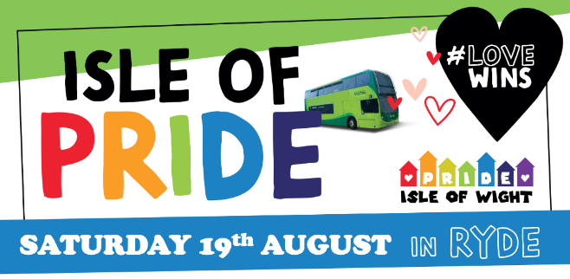

**Image 5 - Southern Vectis Pride banner 2023**

Southern Vectis has supported Isle of Wight Pride, taking part in the Pride Parade in 2023.

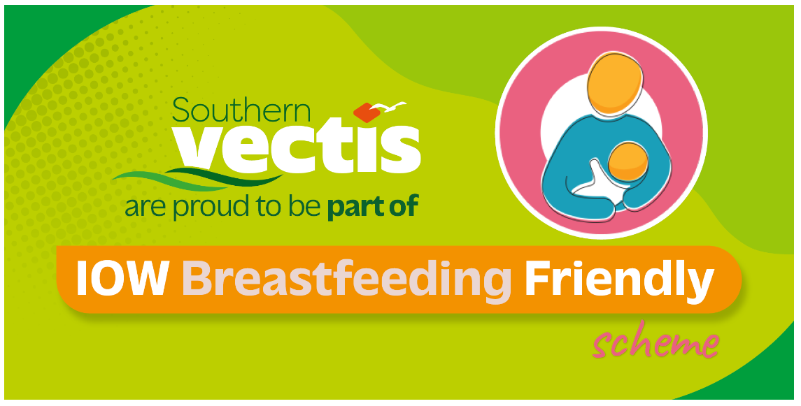

**Image 6 - IOW Breastfeeding Friendly**

Southern Vectis are part of the Isle of Wight Breastfeeding Friendly Scheme

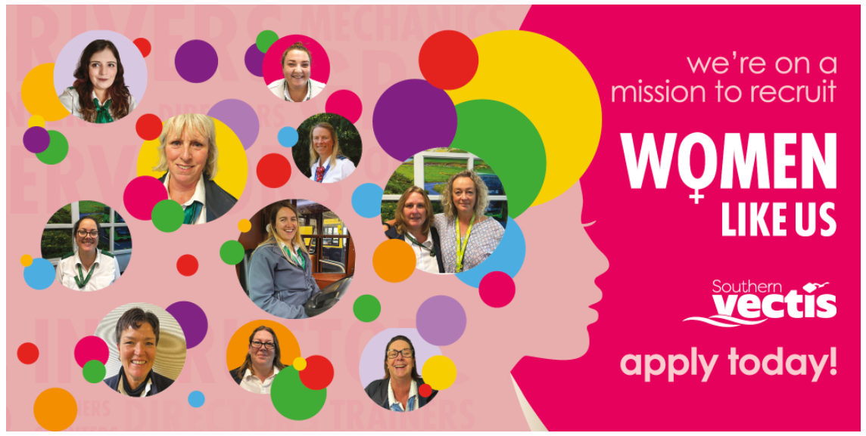

**Image 7 - recruiting women bus drivers**

The Southern Vectis recruitment drive to increase the number of women driving buses.



**Image 8 - Southern Vectis Community Fund banner**

Southern Vectis has a community fund for local charities and organisations to apply for support and funding.

Southern Vectis buses are designed with high accessibility standards, featuring clearly marked spaces for wheelchairs and pushchairs, with the majority of buses featuring next stop announcement technology. Buses are being upgraded so that all meet the Department for Transport's requirements, which mandate that by October 2026, nearly all local bus and coach services must provide audible and visual announcements. These announcements will include the route, direction, upcoming stops, and any diversions. This clear information will not only assist disabled passengers but also benefit those unfamiliar with the route, ensuring they feel confident and secure, especially when traveling late at night.

To enhance accessibility and legibility for all users, the Real Time Passenger Information (RTPI) displays being installed at bus stops will include an audio feature. This audio option is specifically designed to assist visually impaired passengers by providing spoken information about bus arrivals and departures. This ensures that all passengers, regardless of their visual abilities, can access real-time updates and travel with greater confidence and ease.

The Isle of Wight Council (IWC) intends to collaborate closely with community transport operators to help them upgrade their vehicle fleets to meet high accessibility standards. This initiative aims to ensure that all vehicles are equipped with features that accommodate passengers with disabilities, making public transport more inclusive and user-friendly for everyone.

**Personal Safety and Security**

Details of Southern Vectis policies regarding safety and security on their buses can be found in their conditions of carriage[28].

Lighting levels at bus stops are being improved by installing power supplies to key urban bus stops. In urban areas there are already good levels of lighting and CCTV coverage; to aid personal safety, however rural areas do not have the same benefits. IWC plan to look at options for such areas, such as energy saving cameras, triggered by movement, that are powered by solar power.

From July to September in 2024, a pilot was run at Newport Bus station, to make it a “Safe Space” in 2024. Following this pilot, the scheme has been extended until March 2025. It runs on certain Friday and Saturday evenings and New Years Eve, Street Pastors and police officers located themselves in the Southern Vectis travel shop to bolster the confidence of those travelling around the town between 9pm and 1.15am. The bus station became a place of safety for anyone who feels vulnerable or unsafe on a night out. The scheme is a partnership of Southern Vectis, Hampshire and Isle of Wight Constabulary and Street Pastors. Street Pastors are volunteers from various denominations who cover the towns of Ryde and Isle of Wight.

**d) Implementing the Bus Passenger Charter**

Although the Isle of Wight has not yet established a bus passenger charter, it is dedicated to finalising and implementing one within 12 months of publishing this Bus Service Improvement Plan. Southern Vectis, the island's sole commercial bus operator, has already made commitments to support bus users through their Conditions of Carriage[29].

## 5.5 Improvements to the bus fleet

The Isle of Wight has an ambition for further rollout of zero emissions buses on all other routes outside of the ZEBRA round 2 project, focusing on smaller single deck vehicles for town and local community services. Southern Vectis are already future proofing their infrastructure to allow this by installing charging connections in Newport to allow capacity to support up to 42 electric buses.

In the interim an investment of seven new euro 6 engine double deck buses were added to the Southern Vectis fleet in November 2023[30]. These predominately operate on service 1 which serves the key route connecting Newport with Cowes and importantly the high-speed cross-Solent foot passenger service to Southampton.

Additionally, euro 6 engine double deck vehicles will be joining the Southern Vectis fleet over winter 2024 having been transferred from elsewhere within the Go South Coast operating area. These benefit with a refreshed interior and different layout, more akin to the lengthy rural routes 7 and 12 which they will operate on. These will replace older vehicles with lower emission standard engines.

## 5.6 Longer term transformation of the network

The emerging Island Travel Plan (ITP, see section 1.4) is currently in development with consultation planned for 2025. Whilst the ITP is being implemented through its fifteen year life, we anticipate further developments to this BSIP.

Proposals for a Bus Rapid Transit (BRT) system are being considered to enhance connectivity with key cross-Solent services. These will be developed in partnership with neighbouring mainland Authorities as they will connect with mainland Mass Rapid Transit (MRT.) Principally on the Island they will connect with the main foot passenger Cross-Solent Ferry services through to Newport and the Bay Area (Sandown, Lake, and Shanklin). Possibilities that will be explored are for a frequent, limited stop service timed to integrate with the cross-Solent ferry services as well the connecting Islandline services. It is proposed that some of the BSIP 2025/26 funding will fund a study into the concept and feasibility of the proposal. The focus will be on current service numbers 1, 2, 3, 5 and 9 routes.

There is potential for a BRT service to operate on the disused rail line between Shanklin and Ventnor, utilising single-deck zero-emission buses. This plan includes the ambitious re-opening of the tunnel into the former railway station at Ventnor East, which would not only further streamline the route and provide a sustainable, modern transport option for the area, but also safeguard bus access from possible future landslides impacting the road network.

## 5.7 Level of funding required to deliver a better Isle of Wight bus network

Table 2 provides a summary of the Isle of Wight’s proposed schemes, including high level estimated costs.

**Table 2 – List of proposed schemes with high level indicative costs**

|  |  |  |  |  |
| --- | --- | --- | --- | --- |
| **Description** | **Estimated Cost** | **Frequency** | **Possible funding source** | **Notes** |
| Customer offer extensions to concessionary travel on services 6 and 12 for journeys to allow pre-09:30 travel. | £15,375 | Annual | Reliant on future BSIP or S106 funding |  |
| Even out the services 6 and 12 to hourly services. | £189,000 | Annual | Reliant on future BSIP or S106 funding |  |
| £1 flat fare for Friday and Saturdays evenings – (support local nighttime economy). | £616,000 | Annual | Reliant on future BSIP or S106 funding | Cost assumes £3 fare cap remains |
| £1 flat fare for under 21s – feedback from Children’s Social Care is that even with the current £2 national flat fare, charges are too high for young people. | £1,000,000 | Annual | Reliant on future BSIP or S106 funding | Cost based on £3 fare cap |
| Introduction of a free travel scheme for job seekers and new employees. | TBC |  | Reliant on future BSIP | Costs dependent on terms and condition of eligibility and the price of the type and duration of ticket |
| Increase frequency of town service 37 and route 4 Ryde to East Cowes to half hourly during the day and introduce evening service. | £335,000 | Annual | Reliant on future BSIP or S106 funding |  |
| Introduce a revised and more complete Newport town service, encompassing routes 38 and 39, every 30mins daytime and introduce evening service. | £225,000 | Annual | Reliant on future BSIP or S106 funding | We would like to introduce these by 2026. |
| Increase frequency of route 8 to every 30mins daytimes between Newport and Sandown year round. | £250,000 | Annual | Reliant on future BSIP or S106 funding |  |
| Maintain new evening journeys on route 6 & 12. | £91,500 | Annual | Continuation of BSIP funding | Services are being used but not currently financially viable |
| Maintain existing funding for routes 6 & 12 for winter 2025-26 | £53,500 | Annual | Continuation of BSIP funding | Services are being used but not currently financially viable |
| Increase frequency of route 8 to every 30mins from Newport all the way through to Ryde year round. | £500,000 |  | Reliant on future BSIP or S106 funding |  |
| Further rollout of zero emissions buses on all other routes outside of the ZEBRA round 2 project - focus on smaller single deck vehicles for town and local community services. | TBC |  | Reliant on future ZEBRA or BSIP funding | It is envisaged that this will be driven commercially by Southern Vectis as the new charging infrastructure will be in place at their principal depot in Newport. |
| £1.50 fare for travel on town services. | £40,000 | Annual |  | Cost assumes £2 fare cap remains |
| BRT proposals to link in with key cross-Solent services Ryde/Newport and Cowes/Newport (limited stopping service on direct routes) |  |  | Reliant on future BSIP and Integrated Transport Fund Capital allocations | These will tie in with similar services on the mainland for the benefit of Island and cross-Solent travel. |
| Further improvements to bus infrastructure on key priority routes. Potential for mobility hubs at key locations (this would include facilities for e-bikes and e-scooters) – shelters, CCTV and accessibility improvements. | £3,000,000 |  | Reliant on future BSIP, Integrated Transport Fund Capital allocations, s278 works and/or S106 | This would enable the upgrading 20+ of rural and urban bus stops per year over the next 5 years and beyond. With an initial focus on key locations and routes. |
| Further improvements at key interchanges i.e., Shanklin and Yarmouth. | £5,000,000 |  | Levelling Up Round 3 funding, Integrated Transport Funding, future BSIP and any development contributions | Please see section 5.4 a. |
| Roll out RTPI focusing on key routes and key hubs initially, then further rollout | £1,500,000 |  |  | On this basis the aspiration would be to roll out 30+ RTPI systems at bus stops per year |
| BRT service on the redundant rail line between Shanklin and Ventnor operating single deck zero emission buses, this includes re-opening of the tunnel into Ventnor East | £75,000,000 |  |  | Please see section 5.6, this is a long term aspiration |

# Section 6 – EP Governance, targets and reporting and monitoring progress

**The Enhanced Partnership**

Southern Vectis, as the predominant bus operator on the Island, provides the majority of the commercial network of local bus services on the Isle of Wight. Southern Vectis has, since its acquisition by the Go-Ahead Group in 2005, substantially stepped up its investment in new vehicles. Their fleet continues to contain a significant number of double-deckers reflecting the need to accommodate high summer loadings, during the peak tourist season and meet school travel demand within the academic year.

IWC also recognises the important role that the smaller community bus operators play in helping to build successful and reliable services, on the Island; especially to areas where regular bus service provision has declined in the past or doesn’t exist.

The IWC has a good history of effective voluntary partnership working with Southern Vectis, and community bus operators, on the Island. This approach has worked well for IWC, delivering sustained improvements for bus users over more than a decade.

IWC also are fully engaged with the Isle of Wight Transport Infrastructure Board (TIB). IWC set up this board in September 2016, which brings together key transport partners on the Island. These include IWC, represented by the IWC Cabinet member for Transport and Infrastructure, Leader of the IWC and the Assistant Chief Executive, Southern Vectis (bus) and Island Line (train), as well as the three ferry operators. The TIB is vital in supporting formal discussions between IWC and the transport operators and helps support their input as key stakeholders across the Islands transport network as a whole.

It is the shared view of IWC and operators that a single Enhanced Partnership for the whole of the Island will result in better outcomes for bus services on the Island. Given the already close partnership working and strong relationships between IWC and bus operators (Southern Vectis), this approach is considered to be the best way of meeting the high level of ambition outlined in this BSIP, rather than through a franchising approach.

The Isle of Wight BSIP and EP allows IWC to continue its successful and productive partnership working arrangements with its bus operators and neighbouring LTAs, in order to improve the offer to the local community, enhance facilities and develop a partnership that can help expand the commercial bus network on the Island.

## 6.1 Countywide and local targets for journey time reduction, reliability improvements and bus passenger growth

**Table 3- Summary of targets set out in the EP Plan -** NB: The targets related to bus journey times, reliability and passenger levels are initial proposals and may be amended. They will be confirmed once an assessment of data received from bus operators has been completed

| **Ambition** | **Target** | **Dates measured** |
| --- | --- | --- |
| Islandwide | Reduce average bus journey times for bus routes as a whole by 7% by March 2030. | Spring 2025 and then annually |
| Islandwide | Improve bus journey time reliability from 88% to 92% of services operating on time (between 1 minute early and 5 minutes late) by March 2030. | Spring 2023 and then annually |
| Islandwide | Increase by 50% the total bus passenger journeys made using bus services on the Island from 2022/23 levels by 2039/40. | Annually |
| Islandwide | Maintain high bus passenger satisfaction rate of 2024 base of 94% by March 2029. | Annually based on Go Ahead Group’s Bus Satisfaction Survey (possibly to be upgraded by Southern Vectis Island focus survey) |

## 6.2 Specific targets for this BSIP

**Table 4- Summary of specific targets for improvement**

|  |  |  |  |  |  |  |
| --- | --- | --- | --- | --- | --- | --- |
| **Action** | **Measure criteria** | **Measurement method** | **Rationale** | **Start date** | **Monitoring Milestones** | **End Date** |
| Conduct annual bus user perception surveys to rate satisfaction with aspects like punctuality, cleanliness, comfort, and customer service. working with Southern Vectis | User satisfaction scores for various aspects of their journey (e.g., punctuality, comfort, cleanliness). | Annual survey distributed to bus users  Monthly reviews to track progress and adjust strategies accordingly | To gauge user satisfaction and identify areas for improvement in bus services and infrastructure. | 2024 | 2024 survey to be completed by November 2024. Full report by Jan 25 then each year.. | December 2030 |
| Deliver bus passenger growth of 10-15% on services 6 and 12 that are receiving BSIP+ service enhancement pump priming funding | Percentage increase in bus passengers on both targeted routes. | Monthly passenger count reports and comparison with baseline data. | To increase bus usage and improve the efficiency and effectiveness of the enhanced services funded by BSIP+. | January 2024 | Operators pro-actively marketing the enhancements  Monthly passenger figures | December 2025 |
| Improve journey time reliability by 5% on corridors where investment is made in bus priority. | Percentage reduction in bus journey times on targeted corridors. | Before and after monitoring: 1 year before and 1 year after delivery of bus priority measures. | To improve bus service efficiency and reliability through targeted infrastructure investments. | March 2025 | Collection of “before” journey time data from Southern Vectis.  Implementation of SVD bus priority measures by 2026 (completed | Measure “after” journey times in March 2027. |
| Install tap-on tap-off card readers on every bus and capped daily fares by Autumn 2022. | Percentage of buses equipped with tap-on tap-off readers | Progress reports from bus operators.  Monitoring of fare capping implementation. | To enhance convenience for passengers and ensure fair pricing through daily fare caps. | 2024 | Achieved. Tap-on Tap-off card readers installed on every bus, National Single Bus cap introduced. | 2025 |
| Full details of all scheduled service changes 28 days prior to their introduction will be provided (unless when emergency timetables are introduced) and continue to ensure that all roadside information (printed and electronic) will be in place by or on the day of the change. The local authority will ensure that this is publicised on the IWC website and Traveline a minimum of 14 days prior to the introduction of service. | Timeliness of service change notifications (70 days prior).  Accuracy and timeliness of at-stop printed information updates.  Timeliness of information publication on HCC website and Traveline (14 days prior).  Inclusion in real-time feeds from the day of operations. | Review of service change notifications.  Spot checks of at-stop printed information.  Monitoring of HCC website and Traveline updates.  Verification of real-time feed updates. | To ensure passengers are well-informed about service changes in a timely manner, improving their travel experience and reducing confusion. | 2024 | This requirement is being adhered to by operators. | Ongoing |
| To work with bus operators to develop bids for future rounds of ZEBRA funding to enable them to commit to decarbonising their own fleets. | Number of funding bids developed and submitted.  Success rate of funding bids.  Progress in fleet decarbonisation. | Review of bid submissions.  Feedback from DfT on bid outcomes.  Monitoring of fleet decarbonisation progress. | To secure funding for the decarbonisation of bus fleets, contributing to transport decarbonisation in Hampshire, and reducing carbon emissions, in line with HCC’s target to become carbon neutral by 2050. | 2024 | 7 Euro VI emissions specification double deck buses added to the Southern Vectis fleet in Nov 2023, further being added at time of BSIP publication.  Electric buses being introduced Mar 26 after successful Zebra bid. | 2026 then future bid rounds |
| Seek to establish formal engagement with Isle of Wight Bus Stakeholder Forum by April 2022 which will discuss and give feedback on punctuality, vehicle cleanliness, proportion of services operated, information and redress. | Number of forum meetings held.  Range and quality of feedback received.  Implementation of suggested improvements. | Meeting minutes and attendance records.  Tracking of improvements based on forum feedback. | To engage bus users and non-users in improving bus services through regular feedback and consultation. | 2024 | Achieved and ongoing, meeting twice annually. | Ongoing |
| To convene a forum of bus, rail and ferry operators, on the Island, to investigate the demand and opportunity for further integration of tickets across all modes of transport. | Number of forum meetings held.  Range and quality of feedback received.  Implementation of suggested improvements. | Meeting minutes and attendance records.  Tracking of improvements based on forum feedback. | To engage with rail and ferry operatorsto find ways to integrate public transport better to help grow bus use through regular engagement. | October 2022 and ongoing | Achieved and ongoing | Ongoing |
| Two windows per year will be identified when timetable changes (other than emergency timetables, those services operated under contract such as school/university related services and seasonal summer uplifts) are made and this will be publicised by both the local authority and operators. | Dates for timetable changes to be agreed with Southern Vectis |  | To help make it easier for bus users to understand the network and to ensure that the number of timetable changes per year are limited. | April 2022 and ongoing | This is being adhered to by operators. | Ongoing |
| Work with Visit Isle of Wight to double the number of tourists travelling by bus around the Island from 11% in 2017 to 20% by 2040. |  |  |  | 2024-2040 | Ongoing engagement with Visit Isle of Wight via monthly Transport Infrastructure board. Percentage dropped to 8% in 2022. | 2040 |
| Southern Vectis to have 22 new electric buses in service |  |  |  | 2026 | ZEBRA funding awarded. Orders placed for depot chargers and buses. |  |
| Increase use of public transport among council staff to 18% by 2030 (currently at 7%). | Mode share of staff travelling to work by public transport | Staff travel survey | To ensure that IWC leads by example and can acts as an exemplar/ case study for other Island employers | 2025 | To be progressed upon recruitment of officers in 2025  Promote staff discounts for public transport with communications plan via C&E or HR.  Introduce season ticket loans for commuters.  A 20% council discount is available on Southern Vectis buses for season tickets. | 2030 |

**Table 5 - Routes selected for target monitoring (all Southern Vectis)**

| **Bus Number and Route Section** | **Area** |
| --- | --- |
| Route 1 | Horseshoe Inn to Lugley Street |
| Route 2/3 | Ryde BS to Shanklin BS |
| Route 2/3 | Newport BS to ASDA |
| Route 5 | Newport BS to Binfield Corner |
| Route 4/5 | Osborne House to East Cowes Waitrose |
| Route 9 Fairlee Leg | Newport BS to Wootton, Cedars |
| Route 9 Staplers Leg | Newport BS to Wootton, Cedars |
| Route 9 | Wootton Cedars to Ryde BS |

# Appendix A – Background information on demography, travel patterns and bus data

The Isle of Wight is an island county located between two and five miles off the coast of Southern England, from which it is separated by a stretch of sea known as The Solent. It is the largest and second-most populous island in England with a population of 140,459 residents.

The Island has a land area of 38,000 hectares. Slightly more than half of which, mainly in the west, is designated as the ‘Isle of Wight Area of Outstanding Natural Beauty’. The island has 258 km2 of farmland, 52 km2 of developed areas and 92 km of coastline. In June 2019 the whole island was designated a UNESCO Biosphere Reserve, recognising the sustainable relationships between its residents and the local environment.

The Island’s countryside offers a diverse range of natural environments, including rolling chalk downs, ancient woodlands, salt marshes, together with land dedicated to agricultural use. Distributed across the more rural parts of the Island are a number of small villages and hamlets.

There are approximately 800km of adopted highway maintained by IWC. There is no motorway and only a very limited distance of dual carriageway on the Island, with a large majority of the road network located across the more rural parts of the Island.

Urbanisation and greater population density occur in the main towns of Newport, Ryde and Cowes (East and West), with Sandown, Lake and Shanklin linking together down the east coast to form ‘The Bay’ area and almost meeting with Ventnor as the coastline sweeps towards the southernmost tip of the Island.

Tourism equates to 30% of the Island’s economy with 1.96 million visitors spending around £280 million between October 1, 2022, and September 30, 2023. The Isle of Wight boasting some of the most unique landscapes and attractions, in the UK. From picturesque harbours, natural bays and beaches, stunning coastline scenery and chines, to world famous historic buildings and castles. The island offers a great number of well-established holiday parks, hotels, and unique places to stay.

The town of Cowes, located on the west bank of the estuary of the River Medina, to the north of the Island, has long been seen as a home for international yacht racing since 1815. It gives its name to the world's oldest regular regatta, known as ‘Cowes Week’, which occurs annually in the first week of August, attracting over 100,000 visitors each year.

The Island also hosts the Isle of Wight Festival. A large scale music festival which takes place at Seaclose Park, on the outskirts of Newport with up to 70,000 people attending this annual event.

Access to the Island’s assets, events and attractions are supported by the Island’s bus network, and the sole railway connection which runs for 13.7km between Ryde Pier Head and Shanklin, serving Smallbrook Junction, Brading, Sandown and Lake Stations. Southern Vectis, are the main bus operator on the Island, providing services across the majority of the Island, whilst the rail service is operated by Island Line. A number of other smaller local bus operators have provided services on the Island over the years, but none has developed or sustained a significant commercial market share, and Southern Vectis has remained the dominant and fully commercial provider of Island bus services to this day.

Currently there are a small number of community bus services in operation; FYT Bus, which operates exclusively within the West Wight. This is a charity run Community Bus project, run by volunteer drivers. Also Service 31 runs between Bonchurch and St. Lawrence via Ventnor. This operates as a local town service operated by Minibus Plus in partnership with Ventnor Town Council. Additionally, there are a small number of community bus services operated by the Community Bus Partnership, who utilise some Southern Vectis’ vehicles fleet, between home to school lifts, to operate local community services, driven by volunteer drivers.

Access to the Island, across the Solent from the mainland, is provided via six main passenger and car ferry routes, along with a dedicated hovercraft link; the only commercial passenger hovercraft service in the world. Figure 11 illustrates these routes across the Solent.

These routes consist of the following services and connections:

* Portsmouth to Fishbourne - This car and foot passenger service is operated by Wightlink and takes approximately 45 minutes.
* Portsmouth to Ryde - The “FastCat” catamaran foot passenger service, which runs from Portsmouth Harbour to Ryde Pierhead, is operated by Wightlink. This crossing takes approximately 22 minutes.
* Southampton to East Cowes - This service is run by Red Funnel and operates between Southampton and East Cowes, carrying both cars and foot passengers. This crossing takes up to 1 hour.
* Southampton to Cowes - The “Red Jet” offers a high-speed foot passenger service for this route, also operated by Red Funnel running from Southampton Docks to Cowes, taking 28 minutes.
* Lymington to Yarmouth - The quickest vehicle ferry service runs from Lymington in the New Forest to Yarmouth in West Wight, which is operated by Wightlink. Taking 40 minutes.
* Southsea (Portsmouth) to Ryde - The Isle of Wight boasts the only foot passenger hovercraft service in the UK, which runs from Southsea in Portsmouth to Ryde Esplanade and is operated by Hovertravel. This crossing is also the fastest service to the Isle of Wight, taking just 10 minutes.

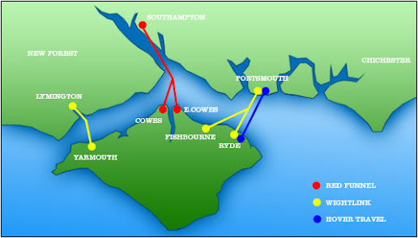

**Figure 11 – Ferry and Hovercraft service links to the Island**

All ferry and hovercraft services allow passengers to take bikes. The Isle of Wight Ferry is historically one of the Island’s most famous features with the first recorded service dating back to 1420. With no fixed link to the Isle of Wight from the mainland (i.e. via road bridge or tunnel) the only mode of transport to and from the Island is by ferry or hovercraft.

Residents and visitors are heavily reliant on cross-Solent services for the movement of people and goods. Maintaining and improving these connections are vital to the economy and overall wellbeing of the Island.

5.5% of Island residents in employment rely on ferries for daily commuting to the mainland, this approximately includes 730 commuters to Portsmouth, 570 to London, and 520 to Southampton. In 2019 the Island welcomed circ. 2.16m visitors, generating an estimated £276m contribution to the local economy.

The mixture of suburban style towns, rural village communities, daily commuters to and from the Island, and the large number of visitors to the Island, all result in a range of transport challenges, faced Island wide. From rural isolation, in the more remote areas of the Island, to poor air quality and congestion in parts of our towns, along with pockets of ‘transport poverty’ and peak season tourist demands. Buses already play a key role in alleviating these problems.

Buses are our most used form of public transport on the Island and make a real difference to people’s everyday lives, allowing them to get to work, to visit friends and family, to access retail, and to get to essential services such as schools, colleges, libraries, GP surgeries and hospitals, as well as helping to support the tourist economy.

The county of Hampshire offers the only commercial gateway to the Isle of Wight, across the Solent. Hampshire County Council (HCC) is the county council that governs the majority of Hampshire. It provides the upper tier of local government there. Two of Hampshire’s coastal cities, Southampton, and Portsmouth provide the main ferry and hovercraft links to the Island. As Unitary Authorities Hampshire, Southampton and Portsmouth are Local Transport Authorities (LTAs) in their own right, and therefore do not form part of the Isle of Wight LTA area.

In 2020, Hampshire had a population of 1.39 million residents, Southampton a population of 253,000, and Portsmouth a population of 214,000. As such the neighbouring Local Authority areas are important employment, retail, and cultural centres. With Southampton and Portsmouth containing two important ports and two major regional hospitals, they see significant cross-boundary travel to and from Island. From the Islands visitor profile data 38% come from Hampshire alone.

The largest towns on the IoW are Ryde in the north-east, with a population of about 30,000, and the county town of Newport as the second largest, centrally located on the island, with a population of about 25,000. Newport is considered to the be the main shopping area for the Island and is home to the IWC offices, HMP Isle of Wight and St Mary’s Hospital, the only NHS hospital on the Island.

Figure 12 illustrates the main road and rail networks and settlements on the Island. The Island's strategic road network is centred around Newport, with routes out to coastal settlements such as Cowes, Sandown, Freshwater and Yarmouth. These key roads along with smaller roads which supplement them, form a total network of over (800km). The layout of the Island’s highway network is driven by a number of factors including the shape of the Island, the River Medina and the locations of towns and settlements.

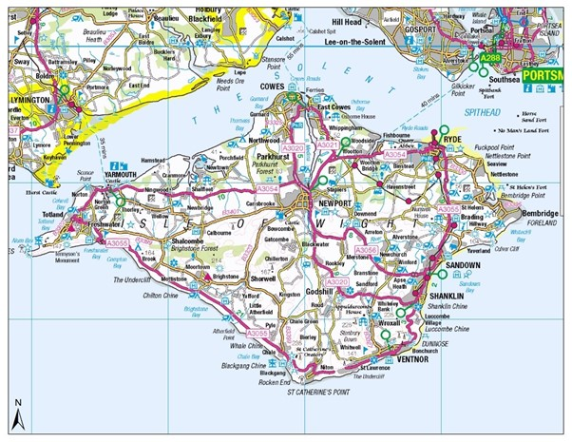

**Figure 12– The main towns, strategic and main A-road networks of the Isle of Wight**

As well as Ryde and Newport, sub-urbanisation population density can also be found in the town of Cowes (East and West) and the seaside resorts of Sandown and Shanklin, linking with Ventnor.

Other much smaller settlements of population include Freshwater, Yarmouth and Totland to the west of the Island, and Seaview and Bembridge to the east. There are a number of rural villages and hamlets scattered across the Island.

The most rural part of the Island is to the south and south-west coastline, which is designated as an Area of Outstanding Natural Beauty. Figure 13 below outlines the population density of the Island as a whole. Whilst the overriding character of the Island is rural, about 60% of the Island’s population live within the main towns of Ryde, Newport, Cowes, East Cowes, Sandown and Shanklin.

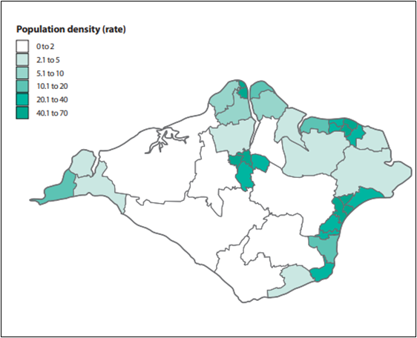

**Figure 13 – Population Density on Isle of Wight (number of people per hectare)**

There are average levels of car ownership across the IoW, with 34.8% of households having two or more cars or vans. 20.8% of households do not own a car or van. There are high proportion of two car households across most rural areas. Levels of car use are also high on the Island, and IoW has diffuse commuting patterns, making certain commuting trips, particularly to the urban areas and ferry connections, difficult to serve efficiently by bus.

**Table 6 – Car ownership percentages Census 2021**

|  |  |  |  |  |
| --- | --- | --- | --- | --- |
| Local Authority / area | No cars or vans in household | 1 car or van in household | 2 cars or vans in household | 3 or more cars or vans in household |
| Hampshire | 13.3% | 38.6% | 34.5% | 13.6% |
| England and Wales | 23.3% | 41.3% | 26.2% | 9.2% |
| Isle of Wight | 20.8% | 44.4% | 25.1% | 9.7% |

Across IoW an average of 2.5% of commuting journeys are completed via bus. Areas surrounding urban centres, such as Newport, Ryde and Cowes show the highest percentages of commuting to work via bus.

The private car or van is the principal mode of travel to work on the Island. The last Census (2021) showed over half, 55% travelled to work by car. In-commuting is highest in Newport, with an overall inflow of commuters. The rural areas as well as the areas on the south of the Island such as Ventnor and Puckaster have large outflows. Walking is the main mode of travel to school (39%), but 34% of pupils are taken to school by car.

Economic and social factors, degrees of rurality and ease of access to public transport all influence car ownership. The proportion of no car households is highest in the more urban areas like Newport and Shanklin/Sandown.

There are localised pockets of deprivation on the Island with significant inequalities in health outcomes. It is widely recognised that poor transport provision can disproportionately affect those in deprived areas limiting access to services, opportunities, and life chances, and contributing to social isolation and loneliness. Figure 14 below outlines the percentages of health and disability depravation on the Island.

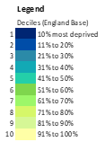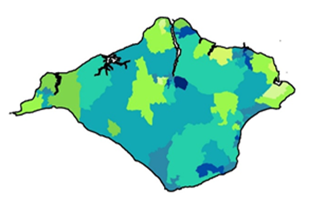

**Figure 14 – Health and disability deprivation (Source: H2050 – State of Economy 2020)**

**Bus fleet information**

Southern Vectis has a fleet of 87 vehicles that serve the Island’s network. The below fleet details were correct as of 31st May 2023.

**Table 7 – Southern Vectis fleet by vehicle type**

|  |  |
| --- | --- |
| Open top bus | 6 |
| Double decker bus | 69 |
| Midibus | 12 |

**Table 8 Age profile (by registration date) of Southern Vectis fleet**

|  |  |
| --- | --- |
| 2008 | 1 |
| 2009 | 12 |
| 2012 | 28 |
| 2013 | 8 |
| 2014 | 2 |
| 2016 | 10 |
| 2017 | 16 |
| 2023 | 7 |

**On-bus facilities and technology**

Currently 39 vehicles have UBS charging points, although none have WIFI connectivity, simply due to the unreliable network reception on various parts of the Island. This is in favour of providing more USB charging facilities on the fleet. 63 vehicles have next stop announcement and screens.

**English National Concessionary Travel Scheme (ENCTS) and local enhancements**

ENCTS users are advised to consult the IoW Council website for up-to date details of where and when you can use you pass (as this section may not be updated.)

ENCTS pass holders are entitled to use buses within England (outside of London) at any time on a Saturday, Sunday or bank holiday, and from 9.30am to 11pm on any other day. Usage in London is further restricted.

At the time of publication of this BSIP, the Isle of Wight Council offers its residents discretionary enhancements to the national travel scheme.

The ‘New Islander Card’ local concession is available to residents who have a ‘severe and enduring’ mental health problem and residents who could not use bus services without the assistance of a travelling companion. The Travelling Companion concession is solely available to island residents who have been issued an English National Concessionary Travel Scheme Concession Scheme bus pass on the grounds of disability, or a New Islander Card issued on the grounds of having a mental health problem. Additionally, Island residents who hold an English National Concessionary Bus pass issued on the grounds of disability or a New Islander Card, free travel is available at any time on any day of the week on eligible local public bus services and Islandline Services.

As of 14th November 2019, the breakdown of pass holders on the Isle of Wight was as follows:

**Table 9 - Concessionary passes issued by IWC.**

|  |  |  |
| --- | --- | --- |
| Concession element | Number of passholders | % of total |
| ENCTS Older persons concession | 29,186 | 80.9% |
| ENCTS Disabled concession | 3,970 | 11.0% |
| Gold New Islander Card Scheme | 1,499 | 4.2% |
| Silver New Islander Card Scheme | 712 | 2.0% |
| Gold New Islander Card Scheme with additional travelling companion | 42 | 0.1% |
| ENCTS Disabled passes with additional travelling companion | 670 | 1.9% |

**Car Parking cost and availability**

IWC develop an island-wide Parking Strategy for the period 2016-2021. The purpose of the strategy was to provide a consistent island wide policy framework for the management of parking across the island, both within Council managed off-street car parks and on-street.

Under section 2.22 within the strategy is states:

As well as the visions and goals set out, the plan also includes six objectives which relate specifically to different aspects of transport, including parking. ‘Objective B – Maintain and improve journey time reliability and predictability for all road users’ addresses the need to address and limit congestion caused by the sheer weight of traffic on the island, particularly during the summer. It states that:

“We will help maintain and improve journey time reliability and predictability by:

* Making the best use of road space;
* Considering suitable locations for the introduction of bus and cycle priority;
* Highway improvements to increase traffic flow (e.g. remodelling of junctions, bus priority, Urban Traffic Control (UTC);
* Co-ordination of road works;
* Improved signage;
* Development of traffic management plans for major events;
* Working with others (including Hampshire Constabulary on traffic and enforcement issues); and Parking enforcement.”

The fact that the Island has a dispersed population means that we experience problems

of a similar nature to other rural areas. The fact that we live on an island with a limited

road network sets us apart and gives us a particular set of challenges and opportunities.

Local traffic congestion is perceived by many as a growing problem, particularly at peak

commuting times, during school holidays and the holiday season when the influx of

tourists means that the Island’s population almost doubles.

The council currently has responsibility for operation, management, and enforcement of

the following:

* 74 car parks, of which 14 are free.
* 18 on-street pay and display locations providing approximately 900 spaces.
* 147 parking ticket machines.
* 37 loading bay locations.
* 114 plated disabled bays (which are enforceable) in 38 streets.
* 19 school ‘keep clear’ locations.
* Park and ride car park, Cowes.

Managing car parks at:

* West Wight Sports Centre Trust, Freshwater;
* Pier Square and the Harbour, Yarmouth;
* The Esplanade, Totland;
* Smugglers Haven, Bonchurch;
* Riverway, Newport

Table 9 below provides an overview of the extent of parking provisions in towns and villages across the Island. All car parks listed are owned and run by IWC.

**Table 10 - Overview of Car Parking for the Island**

|  |  |  |
| --- | --- | --- |
| **Town / Village** | **Total no of local authority short / med stay spaces (including disabled & motorbike bays)** | **Total no of local authority long stay spaces**  **(including disabled & motorbike bays)** |
| Cowes | 75 | 74 |
| Newport | 443 | 863 |
| Ryde | 46 | 820 |
| Sandown | 49 | 561 |
| Shanklin | 159 | 387 |
| Bembridge | - | 67 |
| Carisbrooke | - | 42 |
| Freshwater | - | 288 |
| Lake | - | 79 |
| Seaview | - | 110 |
| St Helens | - | 51 |
| Totland | - | 25 |
| Ventnor | - | 526 |
| Wootton | - | 77 |
| Yarmouth | - | 255 |

**Source: Isle of Wight Council Annual Parking Report 1 April 2019 to 31 March 2020**

**Tariffs﻿﻿ (as of June 2024)**

Short stay off street

up to 30 minutes - £1.20

30 minutes to 1 hour - £2.05

1 to 2 hours - £4.10

2 to 3 hours - £6.15

overnight charge (6pm - 8am) - £2

Long stay off street

up to 1 hour - £2.05

1 to 2 hours - £3.60

2 to 4 hours - £6.20

4 to 6 hours - £8.30

6 to 10 hours - £12.50

overnight charge (6pm to 8am) - £2

Short stay on street

up to 30 minutes - £1.20

30 minutes to 1 hour - £2.35

1 to 2 hours - £4.70

overnight charge (6pm - 8am) - £2.00

Coach

up to 10 hours - £8.50

10 to 14 hours - £17.50

14 to 24 hours - £26.00

**Source: Isle of Wight Council website**

Table 10 below shows the actual expenditure and income for the years ending 31 March 2021, 31 March 2022 and 31 March 2023. All figures exclude VAT.

**Table 11 - Total Expenditure by local authority on car parking including maintenance, ticket machines and enforcement activity in 2020/21/22**

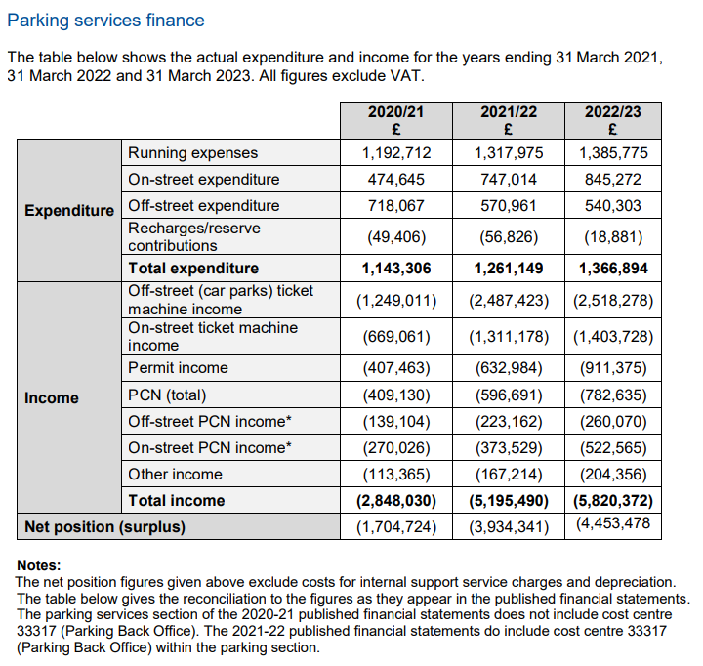

**Source: Isle of Wight Council Annual Parking Report 1 April 2022 to 31 March 2023**

**Expenditure on Marketing of bus services**

Southern Vectis is the only commercial bus operator on the Island and so their marketing effectively promotes the island’s bus network. The island therefore does not have the same joined up marketing needs of mainland local authorities to use their multi-operator networks overlapping neighbouring authorities.

# Appendix B – Local bus market profile routes 1, 5, 9 (routes selected for upgrade to zero emission buses.)

The area covers the Newport, Cowes, East Cowes and Ryde geographical areas, based along the following long established local bus services as a part of the wider local bus service network operated by Southern Vectis which is the local operating company of Go South Coast Ltd These are three of principal routes of the Island’s local bus network. Not only do they connect the urban communities at either end, but they also serve other rural communities along their length such as Wootton (route 9) and Whippingham (route 5).

• Route 1 - Newport to/from Cowes, via Northwood 1 - Newport to Cowes | Southern Vectis

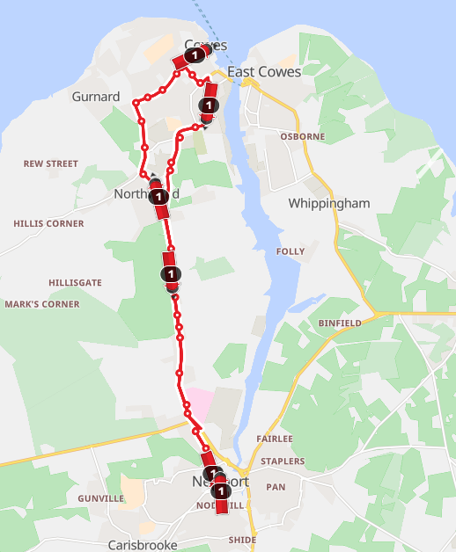

• Route 5 - Newport to/from East Cowes; via Whippingham 5 - Newport to East Cowes | Southern Vectis

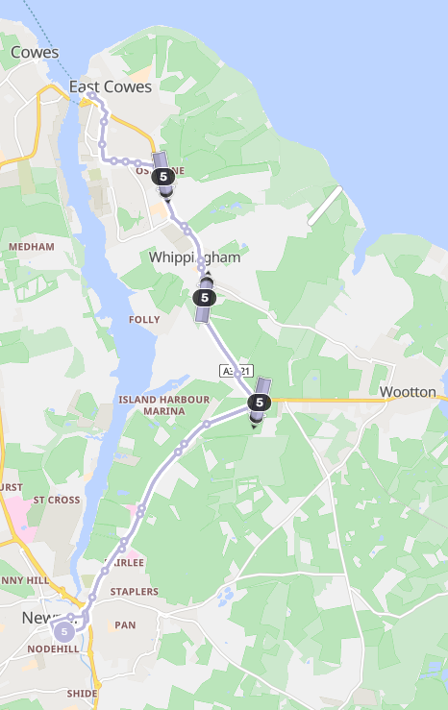

• Route 9 - Newport to/from Ryde, via Wootton, Fishbourne and Binstead 9 - Newport to Ryde | Southern Vectis

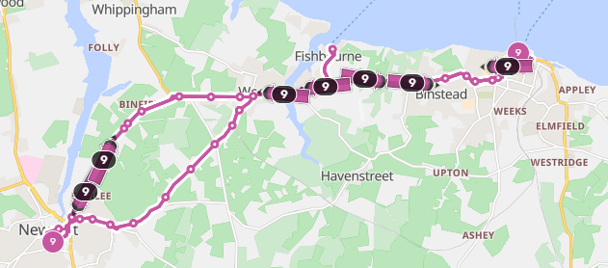

These routes serve a significant proportion of the Island's 140,500 residents, as over 60% of whom live in the main towns of Newport, Cowes, East Cowes, Ryde, Sandown and Shanklin. Likewise, they integrate with the wider transport network at Newport Bus Station, within the centre of the County Town and Ryde Interchange which is within the largest single conurbation.

Likewise, Ryde Interchange is a multimodal transport hub which connects the local bus service network, with cross-Solent ferry services, Islandline rail service and active travel corridors. It has also undergone a significant redevelopment as a part of the wider Portsmouth City Region Transforming Cities Fund Project.

Island Residents travel by bus along these routes to access key amenities including St Mary's Hospital (route 1), Medina Leisure Centre (routes 5 and 9), numerous primary schools, four secondary schools, further education provision, including the Isle of Wight College (route 1) and main retail areas within the towns.

Additionally, these routes connect some larger local employers including the HMP Isle of Wight (route 1), Vestas Technology (route 1), BAE Systems (route 1) and GKN Aerospace (route 5).

These principal services integrate with cross Solent ferry services to mainland England including, Red Funnel high speed Red Jet passenger service (route 1) to/from Southampton, Red Funnel car ferry service to/from Southampton (route 5), Wightlink high speed Fast Cat passenger service to/from Portsmouth (route 9), Wightlink Fishbourne car ferry service to/from Portsmouth (route 9) and the Hovertravel high speed hovercraft service to/from Southsea (route 9). Therefore, whilst these routes are of significant benefit to Island residents, they are also key corridors for visitors and tourists.

Of the 7.17 million journeys undertaken on Southern Vectis local bus services within the year 2022/23, 2.89 million journeys were on these three routes.

# Appendix C – Expenditure on supported local bus and taxi-share services

**Costs of BSIP Phase 2 proposals:**

Grant contributions:  
  
(a) Additional journeys on services 6 and 12 totals £91,500.00 per year

(b) Increased frequency on service 5 totals £145,025.00 per year

(c) Service 6 and 12 winter funding £53,500.00 per year

**ENCTS Discretionary Enhancement costs:**

New Island Card scheme £337,000 (2023/24)   
Disabled persons enhancements £115,000 (2023/24)

**Zebra fund project:**

Grant Contribution: £4,498,988  
Isle of Wight Council contribution £500,000  
Bus Operator funding: £7,784,793

1. [Viewing Document: Corporate Plan 2021-2025](https://iwc.iow.gov.uk/documentlibrary/view/corporate-plan-2017-2020)
2. [Draft Island Planning Strategy](https://www.iow.gov.uk/azservices/documents/2981-Draft-Island-Planning-Strategy-July-2021.pdf)
3. 2570-Mission-Zero-Climate-and-Environment-Strategy-2021-2040-final.pdf
4. 2570-Mission-Zero-Climate-and-Environment-Strategy-2021-2040-final.pdf
5. Annual bus statistics: year ending March 2023 (revised) - GOV.UK ([www.gov.uk](http://www.gov.uk))
6. [Bus statistics data tables - GOV.UK (www.gov.uk)](https://www.gov.uk/government/statistical-data-sets/bus-statistics-data-tables#bus-reliability-and-punctuality-bus09)
7. [Data Viewer - Nomis - Official Census and Labour Market Statistics (nomisweb.co.uk)](https://www.nomisweb.co.uk/census/2011/QS701EW/view/1946157281?rows=cell&cols=rural_urban)
8. [Travel to work, England and Wales - Office for National Statistics (ons.gov.uk)](https://www.ons.gov.uk/employmentandlabourmarket/peopleinwork/employmentandemployeetypes/bulletins/traveltoworkenglandandwales/census2021)
9. [Research & Economic Impact | (visitwightpro.com)](https://visitwightpro.com/research-development/)
10. [Days out & open tops - Southern Vectis (islandbuses.info)](https://www.islandbuses.info/days-out-bus)
11. [Isle of Wight: Military Road could fall in two years, councillor says - BBC News](https://www.bbc.co.uk/news/uk-england-hampshire-68241787)
12. [Car Club (iow.gov.uk)](https://www.iow.gov.uk/car-club/)
13. [Decision - Bus Service Improvement Plus Fund (BSIP+) – Local Bus Service Enhancements - Isle of Wight Council (moderngov.co.uk)](https://iow.moderngov.co.uk/ieDecisionDetails.aspx?Id=609)
14. [Island Roads | Ryde Transport Interchange](https://islandroads.com/current-works/ryde-transport-interchange/)
15. [New Buses for the Island - Southern Vectis (islandbuses.info)](https://www.islandbuses.info/new-buses-island)
16. [Solent Transport (solent-transport.com)](https://solent-transport.com/)
17. [Delivering MaaS with Trafi and their partners – Solent Transport (solent-transport.com)](https://solent-transport.com/maascontract/)
18. [We are UK Bus Operator of the Year! - Southern Vectis (islandbuses.info)](https://www.islandbuses.info/we-are-uk-bus-operator-year)
19. [It's Everyone's Journey - making transport more inclusive - Southern Vectis (islandbuses.info)](https://www.islandbuses.info/its-everyones-journey)
20. [Chance for Isle of Wight passengers to have a say on forthcoming fleet of electric buses - Southern Vectis (islandbuses.info)](https://www.islandbuses.info/chance-isle-wight-passengers-have-say-forthcoming-fleet-electric-buses)
21. [Slow Wight Travel Guide](https://slowwighttravelguide.co.uk/)
22. [Southern Vectis - The Island's Buses - Visit Isle Of Wight](https://www.visitisleofwight.co.uk/information/product-catch-all/southern-vectis-the-islands-buses-p137661)
23. [Southern Vectis optimistic despite commuter numbers still below pre-Covid levels (onthewight.com)](https://onthewight.com/southern-vectis-optimistic-despite-commuter-numbers-still-below-pre-covid-levels/)
24. [Q1-2024-Solent-Transport-Public-Briefing-Paper.pdf](https://solent-transport.com/wp-content/uploads/2024/04/Q1-2024-Solent-Transport-Public-Briefing-Paper.pdf)
25. [NEW FYTBUS SERVICE FOR WEST WIGHT RESIDENTS AND VISITORS OF ALL AGES - Island Echo - 24hr news, 7 days a week across the Isle of Wight](https://www.islandecho.co.uk/new-fytbus-service-for-west-wight-residents-and-visitors-of-all-ages/)
26. [Council secures more than £13.6 million to boost green travel (iow.gov.uk)](https://www.iow.gov.uk/news/council-secures-more-than-136-million-to-boost-green-travel/)
27. [Microsoft PowerPoint - Solent Transport Mobility Hub Design Guide Final Rev 2](https://www.solent-transport.com/hubguide.pdf)
28. [Conditions of Carriage - Southern Vectis (islandbuses.info)](https://www.islandbuses.info/conditions-carriage)
29. [Conditions of Carriage - Southern Vectis (islandbuses.info)](https://www.islandbuses.info/conditions-carriage)
30. [New Buses for the Island - Southern Vectis](https://www.islandbuses.info/new-buses-island#:~:text=We%20are%20delighted%20to%20have,1%20between%20Newport%20and%20Cowes.)